Bernadette (Marse) Tregre

July 1, 1924 – January 31, 2009

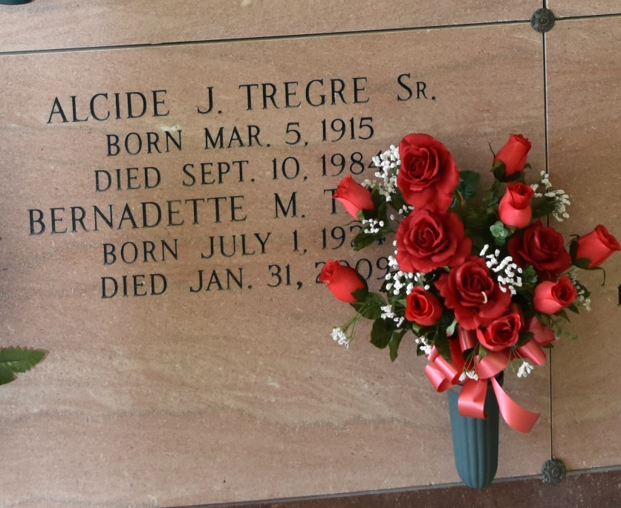

Bernadette Marse Tregre, 84, a native and resident of Vacherie, La., died Saturday, January 31, at 8:05 p.m.

She is survived by her son, Alcide J. “Trigger” Tregre Jr. and wife Lois; daughters, Martha T. Belteau and husband Richard, and Tammy T. Ledet and husband Bryan; brother, Bernard Marse; sisters, Claire “P-Nut” Gauthreaux and Augustine “Teen” Hymel; grandchildren, Mark Belteau, Aline B. Arcement, Vicent Tregre, Jolen T. Stein, Lance Ledet and Scott Ledet; and great-grandchildren, Jada Tregre, Zoe Stein, Duke Stein, Lauren Belteau, Logan Belteau, Lane Arcement and Evan Arcement.

She was preceded in death by her husband of 40 years, Alcide J. Tregre Sr.; parents, Severas and Procla Falgoust Marse; brothers, Augustin “Jean” Marse, Leonard Marse and Severas Marse Jr.; sister, Rita M. Delatte; step-grandsons, Duane Chauvin and Robert Chauvin Jr.; and great-granddaughter, Isabelle Stein.

She was Catholic and a parishioner of Our Lady of Peace Catholic Church in Vacherie. She lived for her children and grandchildren and cherished all her friends.

Visitation will be 8 a.m. to 10 a.m. Wednesday, February 4, at Our Lady of Peace Catholic Church in Vacherie. Mass will be at 10 a.m. with burial at the church cemetery. Samart-Mothe Funeral Home of Raceland, La., is in charge of the arrangements.

Houmatimes.com

Posted Tuesday, February 3, 2009