Theolaine Marie (Ockman) Tregre

August 11, 1926 – December 29, 2003

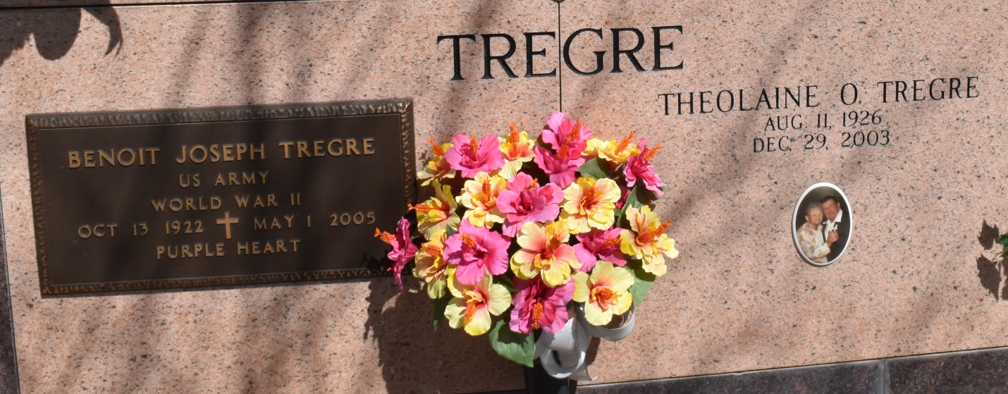

Theolaine Marie Ockman Tregre, 77, a lifelong resident of Vacherie, died Monday, Dec. 29, 2003.

Visitation will be from 8 a.m. to funeral time Wednesday at Our Lady of Peace Catholic Church in Vacherie. Mass will be at 11 a.m. Wednesday at the church, with burial in the church mausoleum.

She is survived by her husband of 60 years, Benoit J. Tregre; one son, Tex Tregre and wife, Catherine of Cut Off; one son-in-law, Donald Martin, of Gibson; six daughters, Cynthia Percle of Chackbay, Gaynell Becnel and husband, Matthew, of Thibodaux, Delane Steib and husband, Ronald, Ramona Kliebert and husband, Michael, Mickey Becnel and husband, Glenn, of Vacherie, and Holly Becnel and husband, Thomas, of Chackbay; 17 grandchildren; four step-grandchildren; nine great-grandchildren; and one step-great-grandchild.

She was preceded in death by her parents, Olympe and Onezem Ockman; one daughter, Sylvia Martin; two brothers, Charles and Lucien Ockman; and three sisters, Lucille Brazan Durocher, Lucette Dempster and Elodise Becnel.

She was a devoted mother and friend to many. Mrs. "Theo" was an active member of the Our Lady of Peace Ladies Altar Society, the Veterans of Foreign Wars Ladies' Auxiliary, the Vacherie Homemakers, and the Perpetual Adoration Adorer.

Samart funeral home is in charge of arrangements.

[www.houmatoday.com](http://www.houmatoday.com)

December 30, 2003