Paul Thomas Triche

June 12, 1960 – January 7, 2021

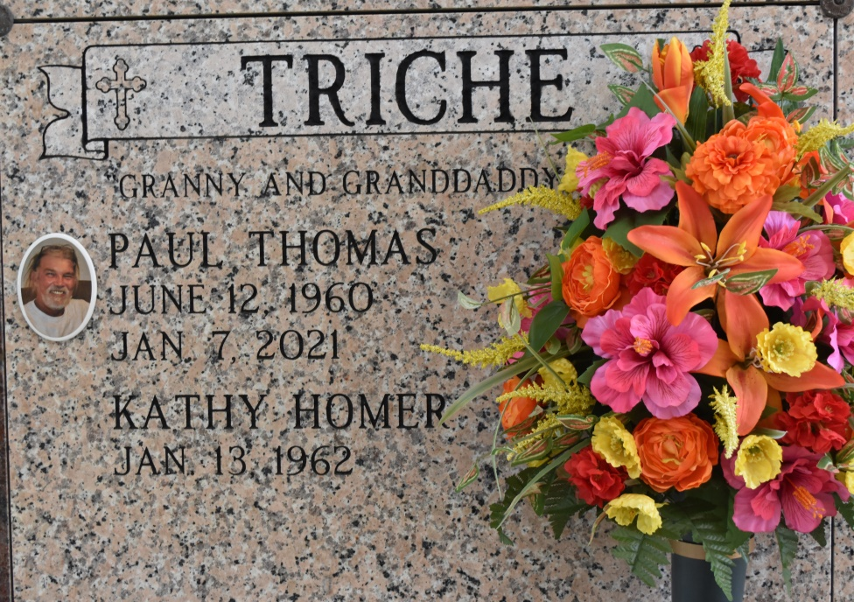

Vacherie - Paul "Grand Daddy" Thomas Triche, 60, of Vacherie, passed away on January 7, 2021.  
 Grand Daddy was always working on something and had his hands in everything. He enjoyed his woodworking and his home projects. After working all day, instead of taking time to relax, he spent his time building things for his daughters, grandchildren and wife. There was nothing in this world that "Grand Daddy" couldn't fix.  
 Visitation will be held Tuesday, January 12, 2021, at Thibodaux Funeral Home from 8:00 am until 10:00 am. The Mass of Christian Burial will be held on Tuesday, January 12, 2021 at Our Lady of Peace Catholic Church, at 11:00 am. Burial will take place in the Our Lady of Peace Cemetery.  
 He is survived by his wife of 36 years, Kathy Homer Triche; daughters, Monique Rodrigue (Ben), Katie Luke (Nick), Tori Triche (Trevor Tweedy); grandchildren, Peyton, Cason and Jolie Rodrigue, Riley and Piper Luke, mother, Beulah Triche; sister, Mona Triche (Kendall). Also cousins who were like brother and sister, Johnny Charles Harmon and Anne Mary Brett.  
 He was preceded in death by his father, Theodule "Butch" Triche Jr.; father-in-law, Jerry Homer; mother-in-law, Katherine Homer.  
 Online condolences can be given at [www.thibodauxfuneralhome.com](http://www.thibodauxfuneralhome.com/).  
Thibodaux Funeral Home is in charge of arrangements.

Houma Today, Terrebonne Parish

Jan. 9 to Jan. 11, 2021