Connie (Falgoust) Troxler

May 4, 1956 – June 28, 2006

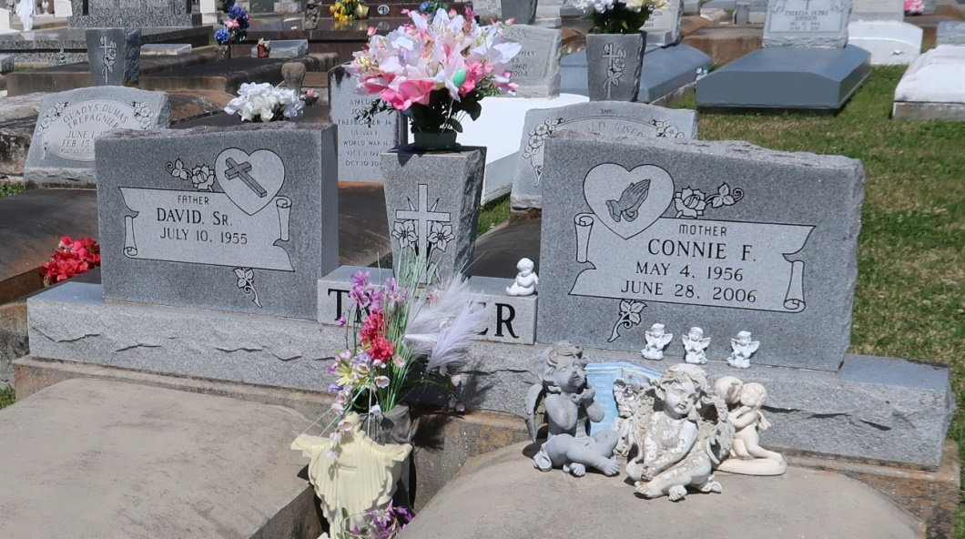

Connie Falgoust Troxler. Age 50. Date of Birth: May 4, 1956. Date and Time of Death: June 28, 2006 at 10:27 p.m. A resident and native of Vacherie, LA.

Visitation 8:00 a.m. until 11:00 a.m., Saturday, July 1, 2006. Our Lady of Peace, Vacherie, LA. Mass of Christian Burial: 11:00 a.m., Saturday, July 1, 2006. Our Lady of Peace, Vacherie, LA. Internment: Our Lady of Peace, Vacherie, LA.

Survived by: David Troxler, Sr.. Parents Harry Falgoust, Therese R. Falgoust. 2 sons: David Troxler, Jr. and John Troxler. 1 daughter: Michelle Troxler. 1 brother: Curtis Falgoust. 1 sister: Kathy F. Oubre.

Preceded in death by grandparents: Vic and Althe Rome and Nazarie and Estelle Falgoust. THIBODAUX FUNERAL HOME, INC., THIBODAUX, LA., IN CHARGE OF ARRANGEMENTS.

The Times-Picayune, New Orleans, LA

June 30, 2006