Marie J. (Dumas) Washington

February 1, 1935 – Octobe 6, 2000

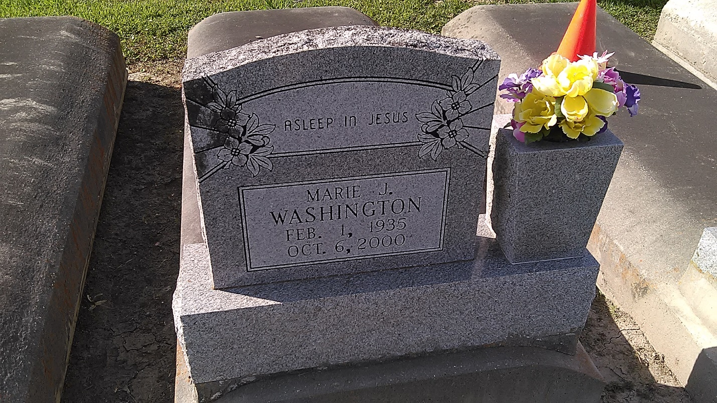

Photo by TMB

Marie Dumas Washington, a homemaker, died Friday of heart failure at Touro Infirmary. She was 65. Mrs. Washington was born in Vacherie and lived in New Orleans for the past 45 years. Survivors include two sons, Alonzo and Chris Washington; a daughter, Debra Washington; her mother, Sadie Marie "Maggie" Dumas; three brothers, Counsul, Norbert and Wesley Dumas; two sisters, Felicia Dumas and Ida Carey; five grandchildren; and a great-grandchild. A Mass will be said today at 11 a.m. at Our Lady of Peace Catholic Church in Vacherie. Visitation will begin at 10 a.m. Burial will be in the church cemetery.

Times-Picayune, The (New Orleans, LA) - Thursday, October 12, 2000

Contributed by Jane Edson