Keith Cleophas Waters

August 18, 1960 – January 26, 2004

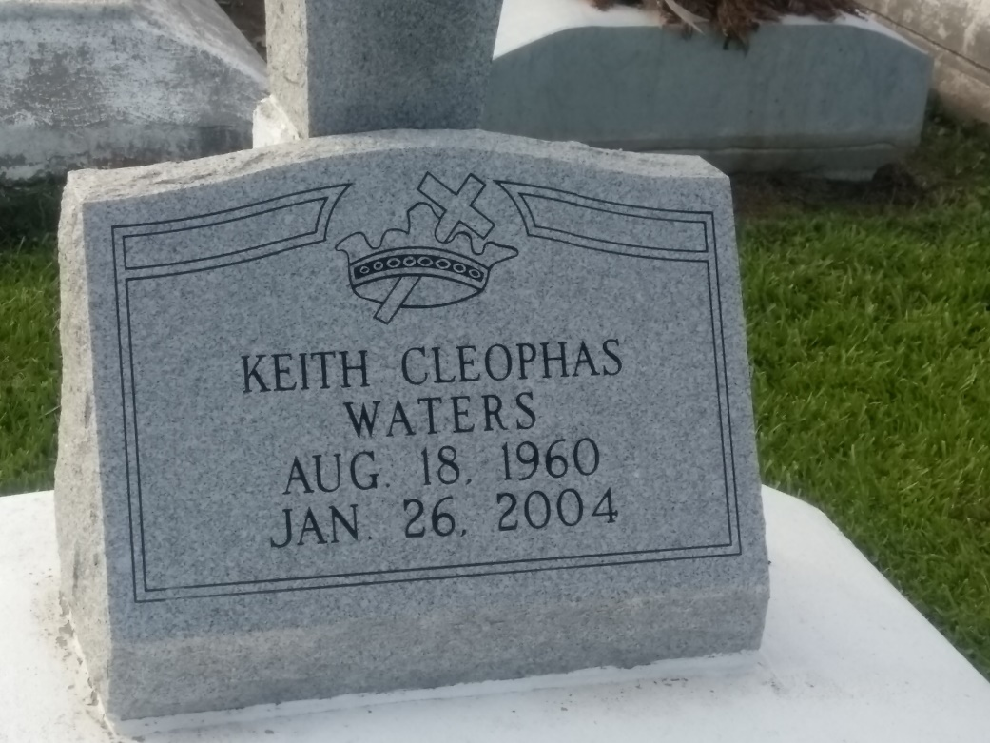

Photo by TMB

Keith Cleophas Waters, an account collector, died Monday of undetermined causes in Marietta, Ga. He was 43. Mr. Waters was a lifelong resident of River Ridge. He attended Bonnabel High School and Louisiana State University. He worked for Focus Receivable Management in Marietta. He was a parishioner of Our Lady of Perpetual Help Catholic Church.

Survivors include his mother, Augustine Becnel Waters.

A Mass will be said Friday at 11 a.m. at Our Lady of Perpetual Help Church, 1908 Short St., Kenner. Visitation will begin at 10 a.m. with a Rosary at 10:15 a.m. Burial will be in Lady of Peace Catholic Church Cemetery in Vacherie.

Times-Picayune, The (New Orleans, LA)

Thursday, January 29, 2004