Mildred Marie (Gravois) Webre
March 20, 1927 – March 30, 2001

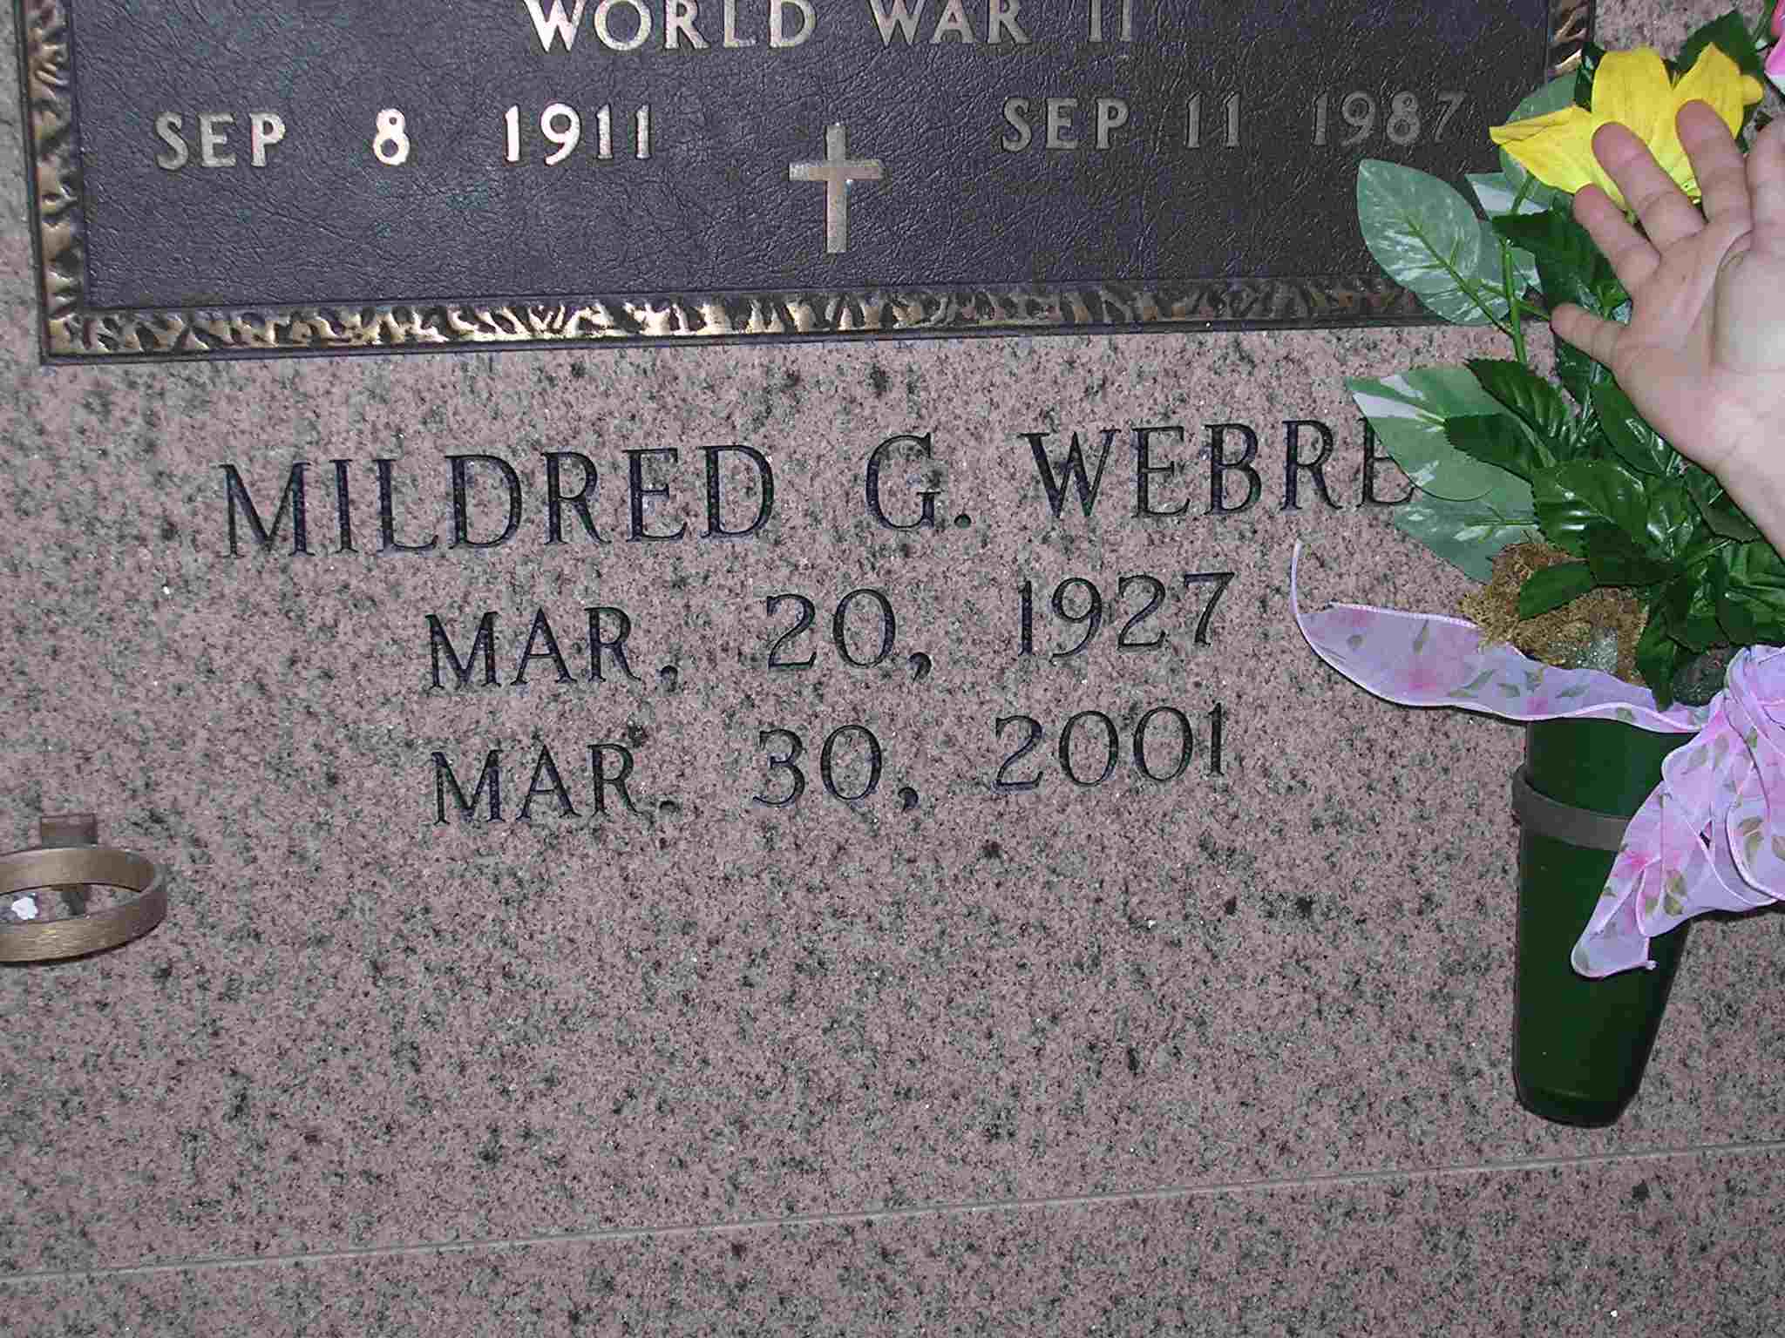

VACHERIE - Mildred Marie Gravois "Millie" Webre, 74, a native and resident of Vacherie, died March 30. She was the wife of the late Roy Webre and mother of Veronica Marchese and Roy Webre. She was also the daughter of the late Felix and Effie Steib Gravois and sister of Lydia Labat, Anne Granier, Virginia Laiche and Francis, Philip, Edwin and Allen Gravois. She was preceded in death by one grandchild.

Services were April 2 at Our Lady of Peace Catholic Church, South Vacherie, with interment at the church mausoleum.

L'Observateur (La Place, LA)
Wednesday, April 4, 2001

