Uranie Marie (Webre) Webre

December 126, 1896 – December 16, 1984

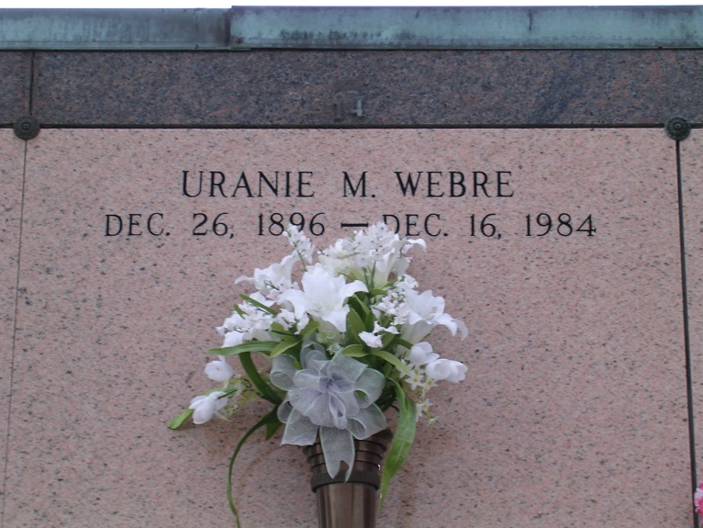

Photo by rrcar

A mass of Christian burial has been scheduled for 10 a.m. Wednesday at Our Lady of Peace Catholic Church in Vacherie for Uranie Marie Webre, 87, a native and resident of Vacherie, who died at 6:30 p.m. Sunday in Thibodaux. Entombment will be in the church mausoleum. Visitation will be from 5 to 10 p.m. today and from 8 a.m. until funeral time Wednesday at the church. She was the mother of Damase Webre of Wallace, Mrs. Leonce (Marguarite) Stein, Mrs. Andrew (Gladys) Kliebert and Mrs. John (Bessie) Rouge of Vacherie, Mrs. Murphy (Mary) Barre of Westwego, Mrs. Frances Williams of Seattle, Wash., and Mrs. Kenneth (Mary Agnes) Wright, of Denton, Texas; stepmother of Ray Webre, Harris Webre and Edward Webre of Vacherie; and the sister of Lucille Bye of St. James. She is also survived by 59 grandchildren, 70 great-grandchildren and a great-great-grandchild. She was preceded in death by her husband John C. Webre; her parents Damase and Euranie Webre; a daughter Mrs. Eurice (Mercedes) Rodrigue; five step-sons Pamphile Webre, Alvin Webre, John Webre, Guy Webre and Norman Webre; two step-daughters Gertrude Webre and Mae Webre; four sisters, Mrs. Andrew Stein, Jeanne Rodrigue, Cornelia Stein and Marguarite Webre; and two brothers, Damase Webre and Remie Webre.

Unknown source