Gail Marie (Simmons) White
May 11, 1960 – January 26, 2001

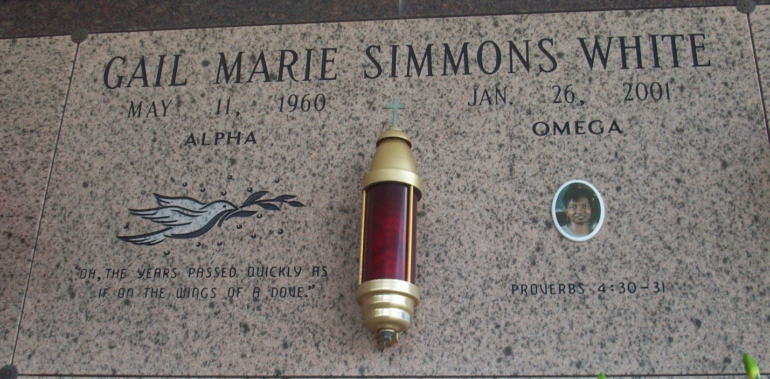
Photo by TMB

Gail Simmons White, a follow-up specialist collector at Tulane Hospital, died Friday of cancer at her home. She was 40. Mrs. White was a lifelong resident of New Orleans. She attended Xavier Preparatory School and graduated from Rabouin High School. She was a member of Beacon Light Missionary Baptist Church.
Survivors include her husband, Kenneth White; two sons, Mandrell J. and Otis A. Easterling Jr.; her father, Albert Simmons Jr.; her stepmother, Williemeaner Simmons; four sisters, Katherine Levy of Vacherie, Katina Brock, Tanya Brock and Albertine Simmons; and a brother, Albert Simmons III.
A funeral will be held Saturday at 10 a.m. at Beacon Light Missionary Baptist Church, 1937 Mirabeau Ave. Visitation will begin at 8 a.m. Burial will be in Our Lady of Peace Cemetery, Vacherie. D.W. Rhodes Funeral Home is in charge of arrangements.

Times-Picayune, The (New Orleans, LA)
Thursday, February 1, 2001

