Edison Joseph Wooden

August 2, 1919 – November 7, 1993

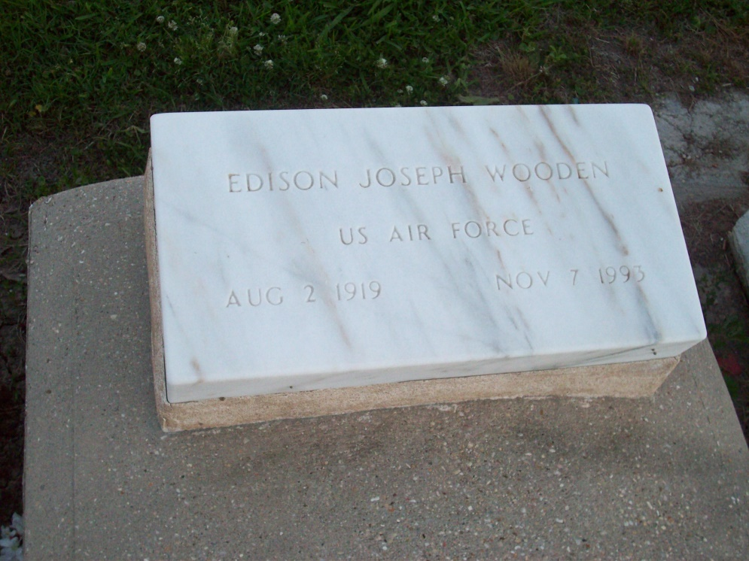

Photo by TMB

A Mass of Christian burial will be celebrated at 11 a.m. Thursday at Our Lady of Peace Catholic Church in Vacherie for Edison Joseph Wooden, 74, a native and resident of Vacherie who died Sunday, Nov. 7, 1993. Visitation will be from 8 a.m. until funeral time Thursday at the church. Interment will be in the church cemetery.

He was the husband of Agnes Dumas Wooden of Vacherie; father of Bertrand Wooden Sr. of Vallejo, Calif., Stanford Wooden of Vacherie, Mary W. Sterling of Vallejo, Ca., Claudia W. Branch of Layton, Utah, Peggy W. Narcisse of McAllen, Texas, Judith W. Favorite, Margaret W. Populus and Carol W. Whitting of Vacherie; brother of Ora Lee Harry of New Orleans and Christina Oubre of Vacherie. He is also survived by 16 grandchildren and five great-grandchildren.

He was preceded in death by her parents, Frank and Margaret Wooden; a daughter, Joan M. Wooden Bryant; and a brother, Ned P. Wooden.

Southall-Westside Funeral Home of Vacherie is in charge of arrangements.

Unknown source

Contributed by Veronica Sampey