Hymel J. Woods

October 3, 1933 – August 23, 2001

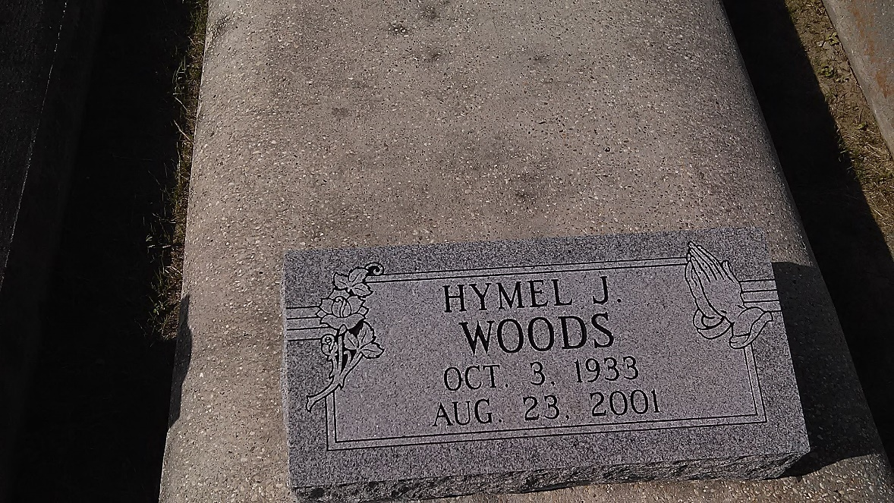

Photo by TMB

SOUTH VACHERIE - Hymel "Mel" Woods, 67, a native and resident of Vacherie, died Aug. 23. He was the husband of Anita Dumas Woods and father of Nannette Young, Lisa Schexnayder, Leslie Johnson, Amos, Deval and Barry Woods.

He was the son of the late Wilson Sr. and Cleona Lewis Woods, and brother of Altas and Wilson Woods Sr., and the late Mary Isom, Frances Keller and Harry Woods.

He is survived by seven grandchildren.

Services were Aug. 31 at Our Lady of Peace Catholic Church, South Vacherie, with interment at the church cemetery.

L’Observateur, Laplace, Louisiana

September 1, 2001