Latricia A. (Steib) Woods
June 12, 1974 – November 28, 2001

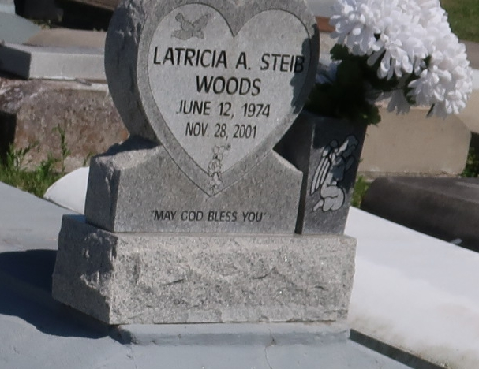

A native of Vacherie and a resident of Rochester, N.Y., she died at 6:14 a.m. Wednesday, Nov. 28, 2001, at Rochester General Hospital. She was 27.
Visiting at St. James Catholic Church, St. James, from 9:30 a.m. Monday until Mass of Christian Burial at noon, celebrated by the Rev. Louis Oubre. Interment in Our Lady of Peace Cemetery, Vacherie.
She is survived by her parents, Hamilton Steib Sr. and Doris Long Steib, both of Vacherie; husband, Jacob Woods, Rochester; three sisters, Michelle Dennis and Gaynell Narcisse, both of Vacherie, and Tonga Henderson, Atlanta; a brother, Hamilton Steib Jr., Vacherie; paternal grandmother, Wilborine Steib; numerous aunts, uncles, nieces, nephews, cousins, other relatives and friends. She was preceded in death by maternal grandparents, Sampson Long Sr. and Mary Luke Long; and paternal grandfather, Hilton Steib. She was the daughter-in-law of Dorothy Woods, Lafayette; sister-in-law of Ita, Trisha, Laura and James Woods; and stepsister-in-law of Nelson and Daniel Woods. Brazier-Watson Funeral Home in charge of arrangements.

Advocate, The (Baton Rouge, LA)
Sunday, December 2, 2001

