Susan (Tregre) Woods

August 20, 1957 – November 19, 2019

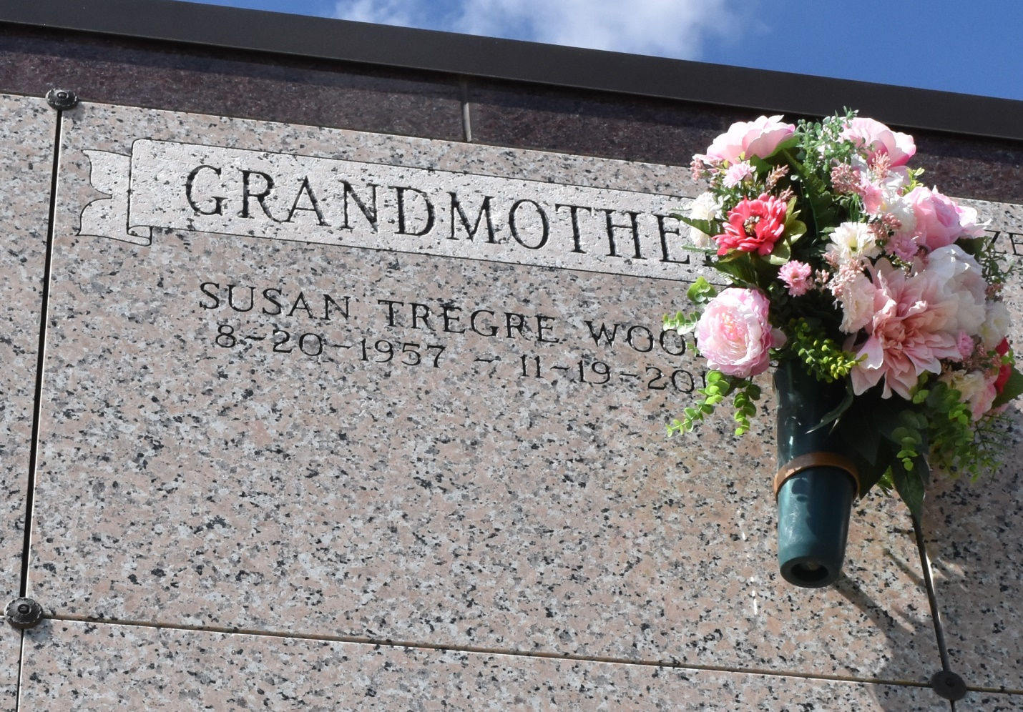

Susan Tregre Woods, 62, passed peacefully surrounded by her children on Tuesday, Nov. 19, 2019, at 9:31 a.m. Born on Aug. 20, 1957, she was a native and resident of Vacherie. A visitation will be held from 8 a.m. until service time on Saturday, Nov. 23, at Our Lady of Peace Catholic Church. Mass of Christian Burial will begin at 11 a.m. at the church, with burial following in the church cemetery. She is survived by her daughters, Jill (Ryan) Griffin, Joni (Iley) Carlos; grandchildren, Guy Woods, Jay Griffin, and Madelyn Carlos; mother, Madeline Mildred Dempster Tregre; sisters, Mary Lee (Carroll) Hymel, Joann (Eddie) Loupe, and Faye (Doug) Crawford; sister-in-law, Pam Tregre. She was preceded in death by her father, Guy Tregre; brother, Mickey Tregre; and nephew, Sgt. Jay Gauthreaux. She loved working with special needs children as a paraprofessional. Her grandchildren were her whole world and she will be dearly missed by so many. The family would like to thank M.D. Anderson Cancer Center for their care. Ordoyne Funeral Home is in charge of arrangements.

Houma Today & The Daily Comet (LA)

Nov. 20 to Nov. 21, 2019