Thelma (Domino) Young

July 18, 1909 – March 31, 1954

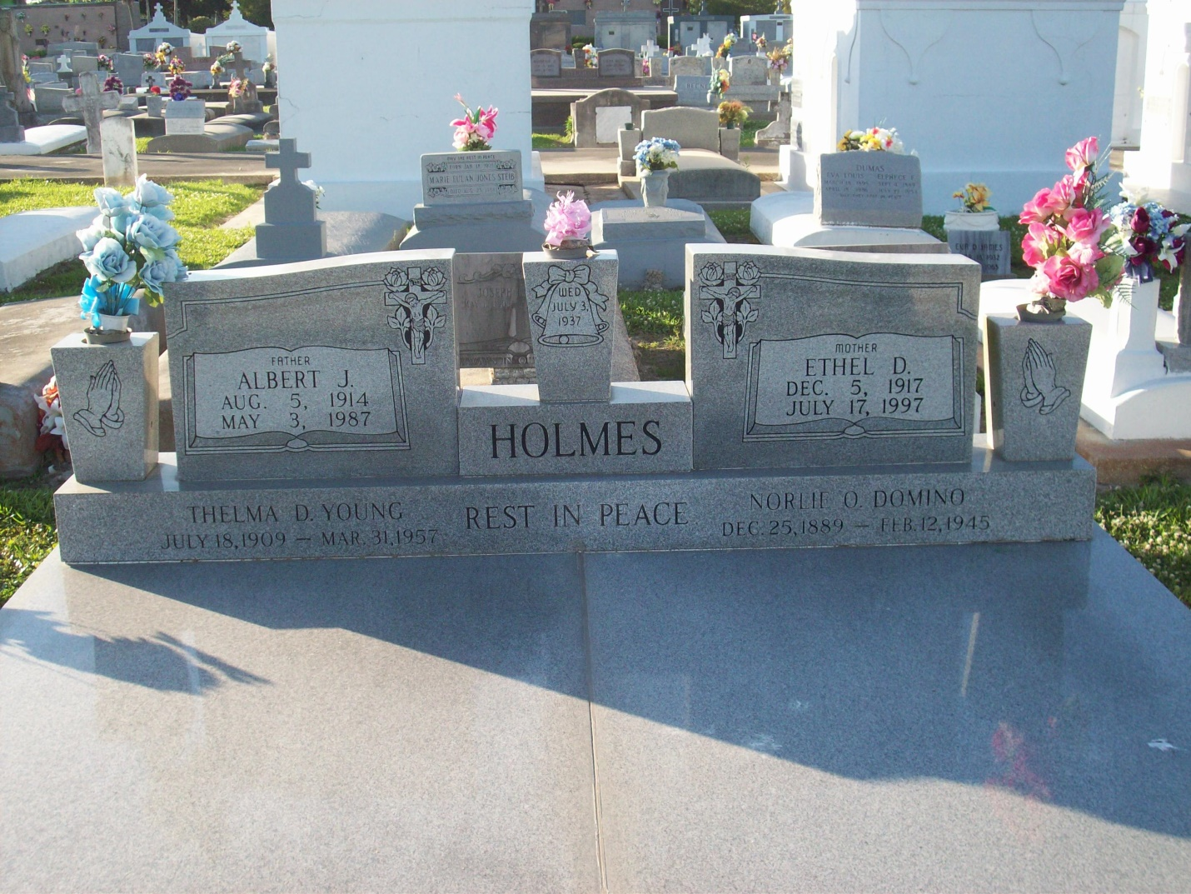

Photo by TMB

YOUNG – On Wednesday, March 31, 1954, at 3:15 o’clock p.m. Thelma Domino Young, beloved wife of Ernest Young; daughter of Nathan Domino; sister of Mrs. Ethel Holmes, Hilton and Wilfred Domino of Marrero, La., Clinton and Horace Domino of Vacherie, La., and Mrs. Alma Triche of Ama, La., also survived by other relatives.

Relatives and friends of the family are respectfully invited to attend the funeral services which will take place on Friday April 2, 1954, at 8:30 o’clodk a.m. from the funera home of the Jsoeph P. Geddes Funeral Service, Inc., 2826 Danneel street, followed by religious services at St. Mary Redemptorist church, 923 Josephine street.

Interment in Our Lady of Peace cemetery, Vacherie, La.

Unknown newspaper clipping

Contributed by TMB