Isabella Leola Gardner
February 4, 1911 - May 26, 2000

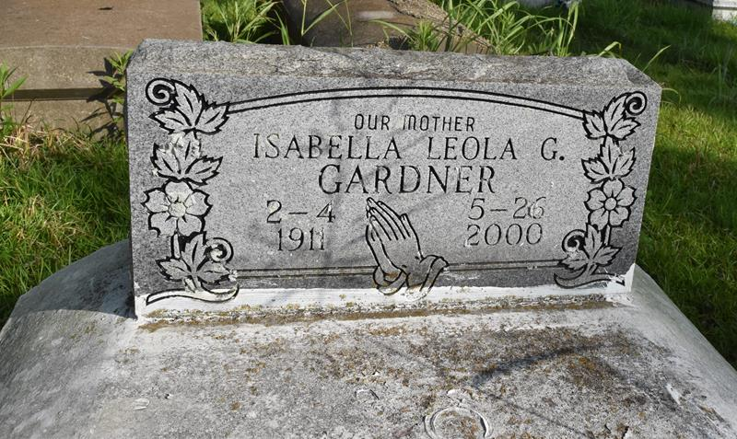

Isabella Leola Gardner, a homemaker, died May 26 at Memorial Medical Center. She was 89. Mrs. Gardner was born in Convent and lived in New Orleans for the past 75 years. She was a member of First House of Prayer Baptist Church, where she served on the Prayer Band and Senior Ushers Board and in the Sunday Church School.
Survivors include a son, Dave Gardner of Dallas; five daughters, Minnie Griffin of Savannah, Ga., Gladys Weathersby of Liberty, Miss., Charlie Mae Marshall, Joyce G. Johnson and Frankie L. Guidry; an adopted daughter, Wanda J. Veals; 17 grandchildren; 29 great-grandchildren; and 16 great-great-grandchildren.
A wake will be held today at 8 p.m. at First House of Prayer Baptist Church, 2826 La Salle St. Dismissal will be Saturday at 9 a.m. Burial will be at Pleasant Hill Baptist Church Cemetery in Convent. D.W. Rhodes Funeral Home is in charge of arrangements.

Times-Picayune, The (New Orleans, LA)
Friday, June 2, 2000
Contributed by Jane Edson

