Ron Darnell Ricks
February 13, 1972 – February 9, 2019

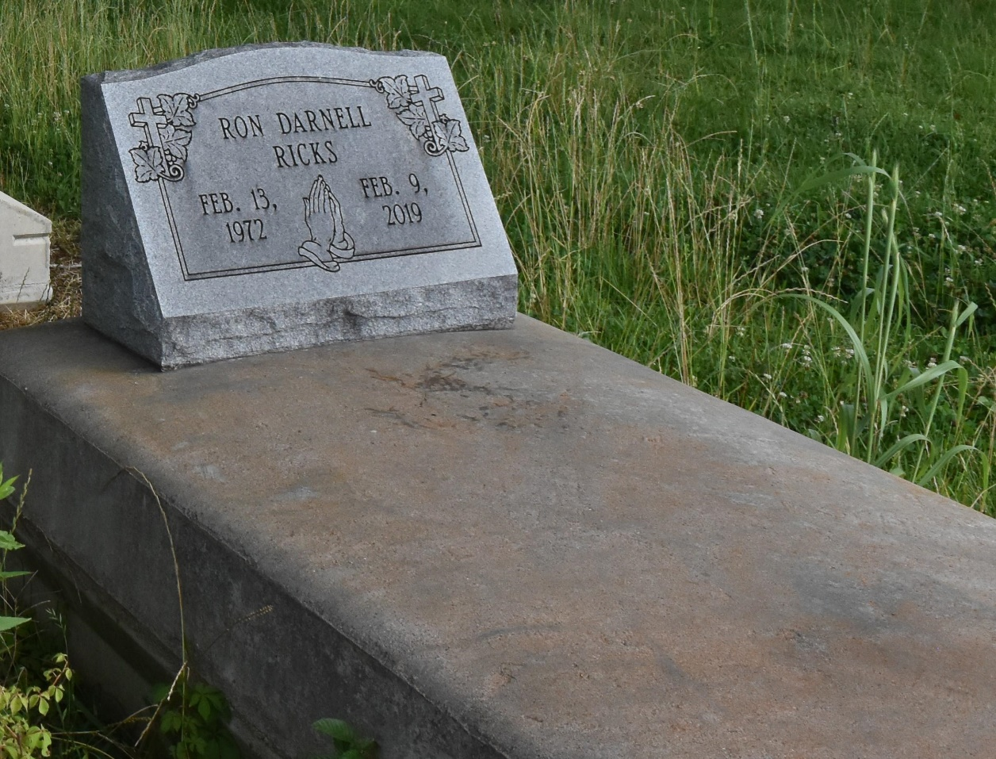

Ron Darnell Ricks, 46, of Convent, LA., died on Feb. 9, 2019 at his residence.
Visiting at Hambricks Family Mortuary, on Friday, Feb. 15 from 5PM-7PM and on Saturday, Feb. 16 at Pleasant Hill Baptist Church, Convent., from 12:30PM until religious service time 11AM. Interment in church cemetery.

Advocate, The (Baton Rouge, LA)
Thursday, February 14, 2019
Contributed by Jane Edson
**
Ron Ricks departed this life on Saturday, February 9, 2019 at his residence. He was 45 years old and a native & resident of Convent, LA.
Relatives & friends are invited to attend the Celebration of Life on Saturday, February 16, 2019 for 1:00 P.M. at Pleasant Hill B.C. 8238 Pleasant Hill St., Convent, LA. Rev. Roderick Williams, Pastor/Officiating. Visitation will be held on Friday, February 15, 2019 from 5PM-7PM at Hambrick’s Family Mortuary in Gonzales and on Saturday from 12:30 P.M. until service time. Burial will follow services in Pleasant Hill Church Cemetery of Convent, LA.

Hambrick Mortuary, Gonzales, Louisiana

