# Dolores Regina (Young) Simmons

October 3, 1939 – May 2, 2002

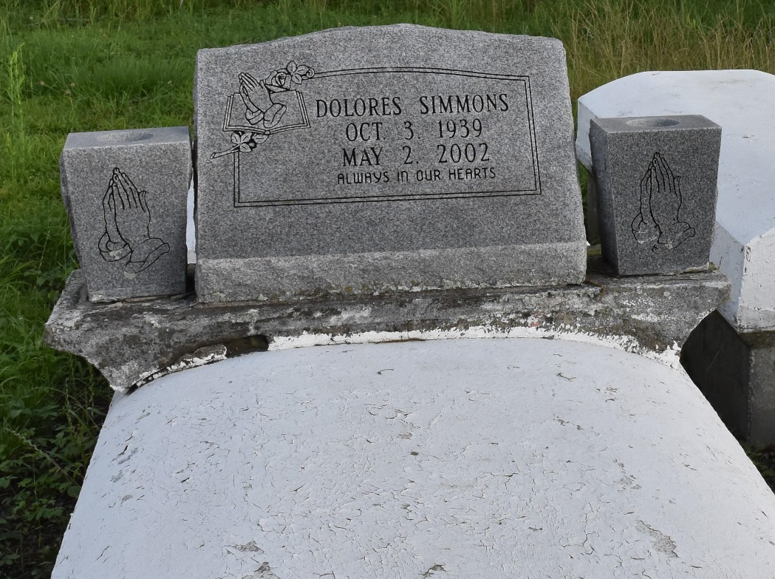

A retired para-professional with the St. James Parish School Board, she died at 4:05 a.m. Thursday, May 2, 2002, at Our Lady of the Lake Regional Medical Center, Baton Rouge. She was 62 and a resident and native of Convent.

Visiting at Pleasant Hill Baptist Church, 8238 Pleasant Hill St., Convent, from 5 p.m. to 9 p.m. Friday. Religious services at the church at 11 a.m. Saturday, conducted by the Rev. Virgil Scott. Interment in church cemetery.

Survived by a son, Marlon Simmons, Convent; four sisters, Frances Howard, Helen Simmons and Alma Simmons, all of Convent, and Gloria Fields, Reserve; two brothers, Mose Simmons and Preston Joseph Jr., both of Reserve; four grandchildren and a great-grandchild.

Preceded in death by her parents, Louiza and Nathaniel Young; four brothers, Joseph, Mack and Nathaniel Simmons and Melvin Davis; and four sisters, Viney Simmons, Myrtle Sandifer, Sophia Hall and Emelda Seio.

She attended Southern University and was a member of St. James Citizens for Jobs and the Environment, Louisiana Neighbor Project and Greenpeace.

Demby & Son Funeral Home, Donaldsonville, in charge of arrangements.

Advocate, The (Baton Rouge, LA)

Thursday, May 9, 2002

Contributed by Jane Edson