Helen Mary Simmons
April 10, 1927 – September 8, 2009

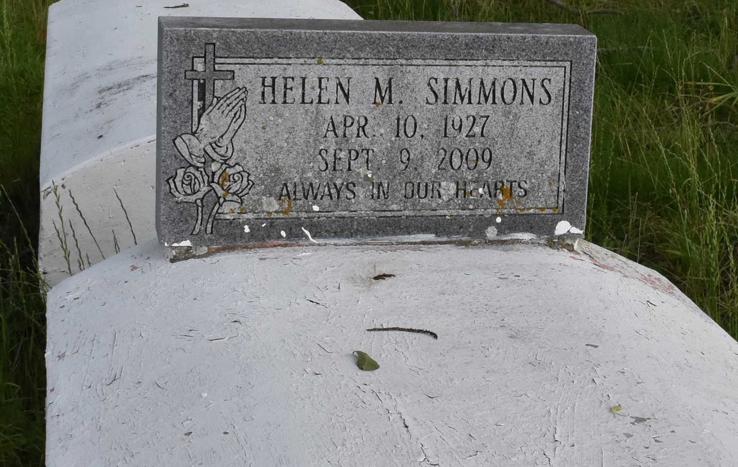

A native and resident of Convent, she departed this life on Tuesday, Sept. 8, 2009, at age 82 in Lutcher. She was the mother of Dianna Honor and Alston Robinson, sister of Alma Hayes, Gloria Fields and Preston Joseph Jr. Also survived by 10 grandchildren, 18 great-grandchildren, two great-great-grandchildren and a host of nieces, nephews, other relatives and friends.
Pastor, officers and members of Pleasant Hill Baptist Church and all neighboring churches are invited to attend the funeral service at Pleasant Hill Baptist Church, La. 44, Convent, on Saturday, Sept. 19, at 11 a.m., the Rev. Virgil Scott, pastor, officiating. Visitation at the church from 10 a.m. until service. Interment in the church cemetery. Service Entrusted to Hobson Brown Funeral Home, Garyville, (985) 535-2516.

Advocate, The (Baton Rouge, LA)
Thursday, September 17, 2009
Contributed by Jane Edson

