Jessie Rose (Johnson) Singleton
February 2, 1951 – January 10, 2002

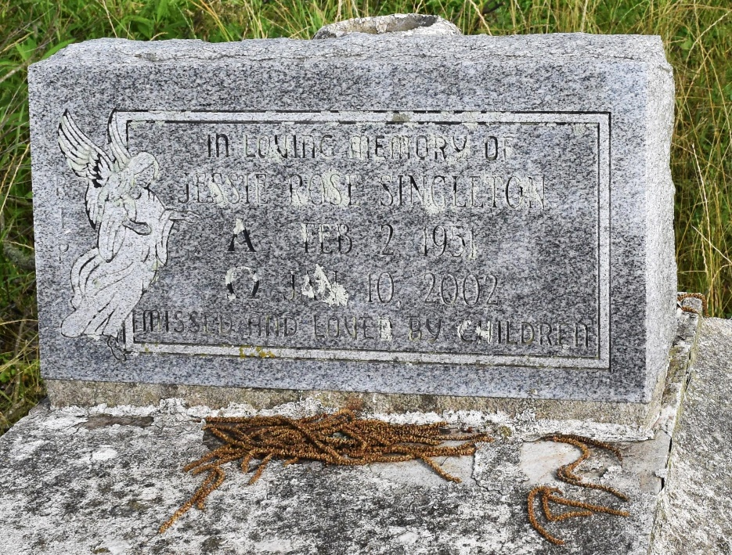

SINGLETON, JESSIE JOHNSON

A native of Newellton and a resident of Convent, she died at 8:20 a.m. Thursday, Jan. 10, 2002, at her residence. She was 50. Visiting at Pleasant Hill Baptist Church, Convent, from 9:30 a.m. Saturday until religious services at 11 a.m., conducted by the Rev. Virgil Scott. Burial in church cemetery.
Survived by her husband, Isaac Singleton Jr.; three daughters, Bessie Scott, Convent, Carolyn Johnson, Paulina, and Gwendolyn Lumar, White Castle; five sons, Isaac Singleton III, Paulina, Rober Singleton, Gramercy, and Roy, Anthony and Andre Singleton, all of Convent; four sisters, Abe Keys and Josie Lowe, both of Detroit, Bessie Tyler, Washing state, and Marshalette Vallery, Convent; two brothers, Robert Johnson, Paulina, and Walter Wattley, Pineville; 14 grandchildren, nieces, nephews, cousins, sisters-in-law, brothers-in-law, sons-in-law, daughters-in-law, other relatives and friends.
Preceded in death by her parents, Robert Johnson and Katie Guerlley; a sister, Katie Rose Thompson; two brothers, John and Alonzo Winston; and a granddaughter, Jaquilla Scott. Brazier-Watson Funeral Home, Donaldsonville, in charge of arrangements.

The Advocate, Baton Rouge, Louisiana
Friday, Jan. 18, 2002, page 13-14A

