Florestine (Mayho) Ambrose

February 6, 1919 – March 3, 2005

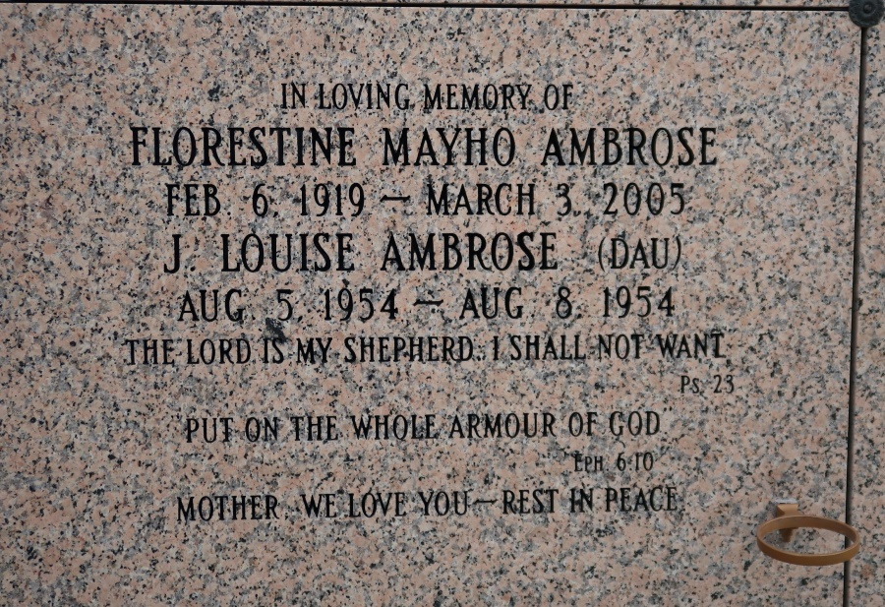

Florestine Mayho Ambrose Of St. James, La On Thursday March 3, 2005 At West Jefferson Hospital. Daughter Of The Late Eugene And Louella Watson Mayho. Wife Of The Late Joseph Ambrose, Sr. Mother Of James Phillip Ambrose Of Vacherie, Jules Ambrose, Sr. New Orleans, Jerralyn Ambrose-Bazile Of Harvey, Joyce Ann Ambrose Hazelwood Of Mareno Valley, Ca, Jerome Ambrose Sr. Vacherie, Janice Ambrose Roussell, Atlanta, Ga, Jesse Stephenson Ambrose, New Orleans, Joshua Joseph Ambrose, Montgomery, Al, John Louis Ambrose, Laplace, Jacob Eugene Ambrose, Jeffery Anthony Ambrose, New Orleans And The Late Joseph Ambrose, Jr. And Louise Ambrose. Sister Of Ernestine Mayho Jackson, And The Late Rose M. Green, Myrtle M. Treaudo, Gladys M. Marshall, Charles, Eugene Mayho Jr. And Joseph E. Weber. Also Survived By (2) Sons-In-Law, (4) Daughters-In-Law, (40) Grandchildren, (37) Great Grandchildren, A Host Of Nieces, Nephews, A Brother-In-Law Lawrence Ambrose Sr., Other Relatives And Friends. A Native And Resident Of St. James, La. Age 86 Years.

Relatives And Friends Of The Family Also Priests And Parishioners Of The St. James Catholic Church, St. Luke B.C. Of St. James, La, Christian Congregational B.C., New Zion B.C. Marrero, New Birth Cathedral Church- Lithonia, Ga, Cathedral Of Prayers-Riverside, Ca, New Creation Christian Church, St. Maria Gorretti, Pure Light Miss. Bapt. Ed. Assoc., Employees Of Dept. Of Defense, Local Union No. 60, U.S. Postal Services, Orleans Parish School Board, Occidential, Members Of Friends Of Faith Society Are Invited To Attend A Mass Of Christian Burial On Friday, March 11, 2005 At 11:00 Am   
From The St. James Catholic Church, St. James, La. Father Louis Oubre Celebrant. Entombment Church Mausoleum. The Baloney Funeral Home Garyville, La.

Times Picayune, New Orleans, LA

March 10, 2005