Judith Ann (Winfield) Ambrose

April 2, 1952 – July 6, 2014

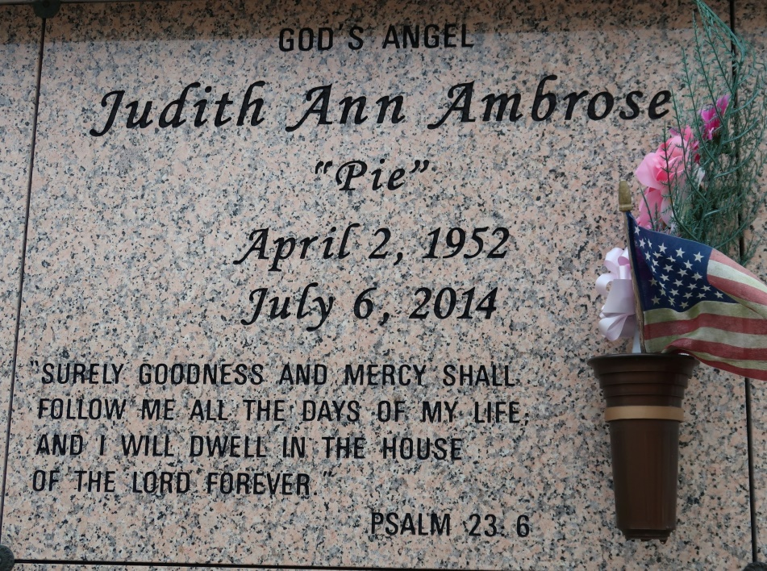

Judith Ann "Pie" Winfield-Ambrose, went to be with the Lord on Sunday, July 6, 2014 in Alexandria, VA, at the age of 62 years old. Daughter of the late Thomas and Velma Winfield, Jr. Mother of Joelle and Jules Ambrose, Jr. Devoted friend of Derry McNeil. Former wife of Jules Ambrose, Sr. Grandmother of Dajon Porter. Sister of Dianne Winfield, Cecilia (Leodis) Harrell, Margaret Dorsey, Paul (Marchillia) Winfield, Wilbert (Brenda) Hogan and the late Thomas Winfield, III. Also survived by a host of nieces, nephews, cousins, other relatives and friends.

Funeral services will be held at St. James Catholic Church, 6613 Highway 18, St. James, La., Saturday, July 19, 2014 at 11:00 a.m. Visitation will be from 9:00 a.m. until time of service. Father Christopher Decker will be officiating. Interment will be at St. James Catholic Church Cemetery, St. James, La. Funeral entrusted to The Baloney Funeral Home, LLC, 1905 W. Airline Highway, Laplace, La., 985-224-8460. Condolences can be expressed at [www.baloneyfuneralhome.com.](http://www.baloneyfuneralhome.com/)

Published by The New Orleans Advocate (LA) from Jul. 16 to Jul. 19, 2014.