Jules Ambrose Sr.
April 18, 1942 - June 22, 2023

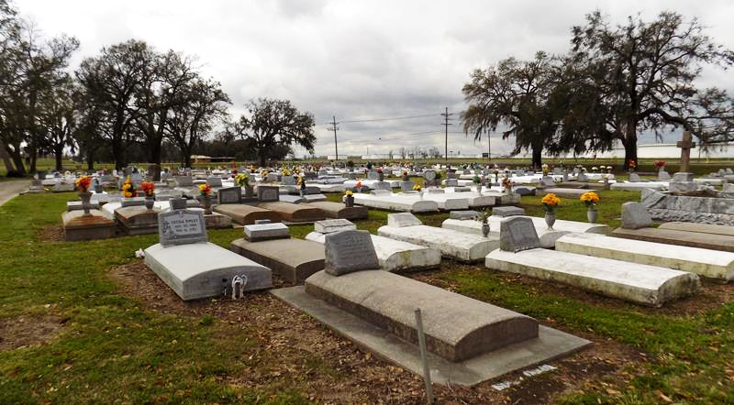

Jules Ambrose, Sr. of New Orleans, LA passed away peacefully at University Hospital in New Orleans, LA., God dispatched his Angel with instructions to release Jules from all his pain and suffering. He fought a good fight, kept the faith, and finished the race.
Born to Florestine and Joseph Ambrose, Sr. 18 April 1942 in Chopin, Louisiana (St. James, LA). He was the third of 12 children and grew up in Moonshine, LA. Jules worked with his other brothers assisting his father who worked as a sugar cane farmer at the time. He attended Cedar Grove Elementary School and graduated from Magnolia High School in May 1960. After high school Jules joined the United States Air Force in June 1960, and was honorably discharged in August 1965 in France and lived in Copenhagen, Denmark until returning home in March 1966. Jules returned to work in New Orleans for several months and moved to Los Angeles, California. There he attended and graduated from Los Angeles City College with an Associate of Arts degree June 1969. After receiving an associate degree, he worked in the oil field until receiving a job at Monsanto Chemical Company as an operator.
Jules met the love of his life; Judith Ann Winfield and they were married In Dec 1970. Jules was very focus driven and, in an effort, to achieve more he resigned from Monsanto in 1971, and attended Xavier University as the first and model graduate of the Xavier’s Career and Opportunity Program, May 1973. Jules taught school for half a term and was then hired as a Federal Civil Servant assigned to the U.S. Navy in January 1974.
He had no idea that his career would flourish and would receive various assignments over the next 30 years. Jules was assigned to the Naval Air Station, in Kingsville, Texas for a year, then moved on the Naval Service School Command, San Diego, California. He then moved to Pensacola, FL in January 1976, and graduated from University of West Florida with a Master of Education in Educational Leadership August 1979. He took an assignment in Alexandria, Virginia (Washington, DC) October 1978. He continued to work for six years as the curriculum development manager with a U.S. Navy program to build ships, training systems and training programs to develop and expand the Saudi Arabian government. The next 17 years he worked as a program analyst managing programs to expand the defense systems of the Indonesian Navy, the South Korean Navy, the Australian Navy, Malaysian Navy, the Japanese Navy, the Navy of Thailand, and the Kuwaitt Navy. He finished out his career as a U.S. Navy Foreign manager supporting Italy, Australia, Spain, England, France, Denmark, Sweden, Norway, Canada, Germany, and other countries in the development of Unmanned Aerial Vehicle technology. His journeys would cause him to travel more than 2 million miles by air crossing the Pacific Ocean more than 200 times, the Atlantic Ocean more than 50 times, earning the title from his peers as the “Globe Trotter.”
He retired from the Federal Civil Service on 30 September 2003, moved back home to New Orleans, LA. After the devastation of Hurricane Katrina in 2005, Jules returned to the city and rebuilt his home in 2006. Jules was “full of life” and was the ”glue” that brought generations of family members together for his annual 4th of July cookout. In November 2019 Jules fulfilled a lifelong goal and was baptized in the Jordan River. He dedicated the rest of the life to bringing a smile to everyone he encountered, supporting family members, sharing his wisdom, and giving us everlasting memories.
He is survived by two children from his wife Judith Ann Ambrose, Joelle Andrea Ambrose (eldest child) and Jules Ambrose, Jr. (youngest child). He is also survived by son Neal Smith his wife Shevonna Smith; their two children Neal Smith,Jr, (grandson) and Gyana Smith (granddaughter). Christopher Perkins (grandson), Bryanna Smith (granddaughter), Kaliyah Smith (granddaughter), and Malia Dale (granddaughter). Five brothers: Jesse Ambrose and Jeffery Ambrose of New Orleans, LA; Jerome Ambrose (Lolita) of Vacherie, LA; Joshua Ambrose of St. James, LA; Jacob Ambrose (Patrice) of Lafayette, LA. Three sisters: First Lady Jerralyn Ambrose-Bazile (Elvin) of Harvey, LA; Joyce Ambrose of LaPlace, LA; Dr. Janice Roussell (Dwight) Atlanta, GA.
Proceeded in death by his wife Judith Ann Ambrose, and parents Joseph and Florestine Ambrose, Sr. Three brothers, Joseph Ambrose Jr., James Ambrose, Louis “John Boy” Ambrose Sr., and one sister Louise Ambrose.
Relatives and friends are invited to attend a public visitation Friday, July 7, 2023, from 1-3pm at Treasures of Life Funeral Services, 315 E. Airline Hwy., Gramercy, LA 70052. A Mass of Christian Burial in honor of Jules Ambrose Sr will be held Saturday, July 8, 2023 at St. James Catholic Church, 6613 Highway 18, St. James, LA 70086. Visitation starts at 9:00am. Mass will begin at 11 am. Entombment to follow at St. James Catholic Church Cemetery, Highway 18, St. James, LA 70086.

Treasures of Life Funeral Services, Gramercy, Louisiana
July 31, 2023

