Raymond Numa Anderman

October 18, 1925 – May 12, 2006

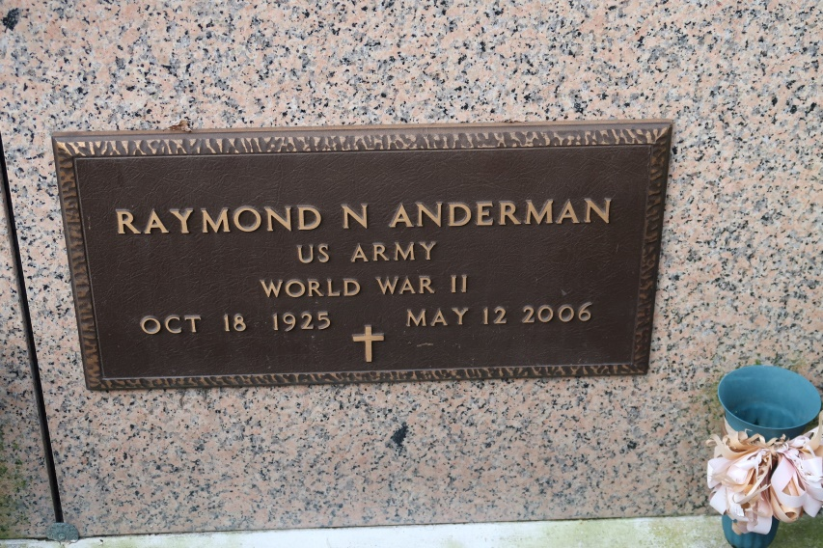

Anderman, Raymond Numa, a retired maintenance supervisor for Greenwell Springs Hospital, died Friday, May 12, 2006, at 8:54 p.m. in Thibodaux. He was 80, a resident and native of St. James and a U.S. Army veteran of World War II.

Visiting at St. James Catholic Church, St. James, on Monday, May 15, from 8 a.m. until Mass of Christian Burial at 11 a.m., celebrated by the Rev. Louis Oubre. Entombment in the church mausoleum.

He is survived by his wife, Cecile Webre Miller Anderman of St. James; two stepdaughters, Carolyn M. Veillon and Juanita M. Rousel, both of Vacherie; two sisters, Marie A. Tregre of Hahnville and Marian A. Poirier of Grand Bay, Ala.; a brother, Louis Anderman of St. James; numerous nieces and nephews, five step grandchildren and a step great-grandchild.

He was preceded in death by his first wife, Elsie Mae Smith Anderman; parents, Antoine and Emma Hymel Anderman; a sister, Anita A. Spears Porter; and brother, Clarence Anderman.

Ourso funeral Home of Donaldsonville is in charge of arrangements.

The Advocate, Baton Rouge, LA

Sunday, May 14, 2006, Page 28A  
Contributed by Jane Edson