Leslie Charmaine (James) Arceneaux

November 18, 1966 – September 14, 2004

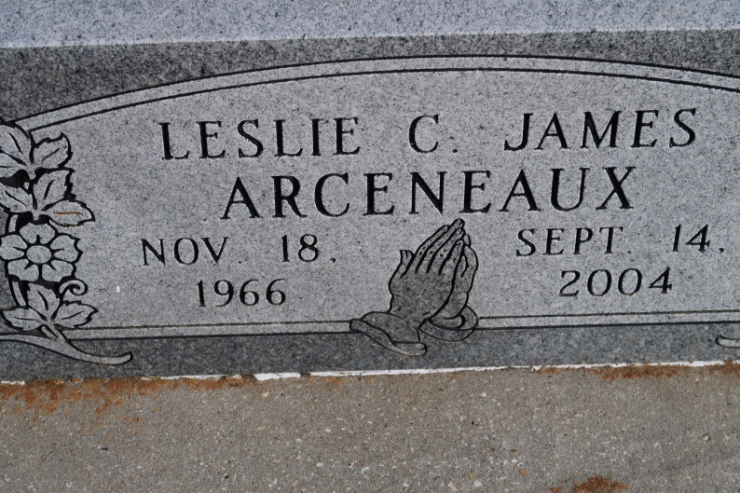

Died Tuesday, Sept. 14, 2004, at 12:45 a.m. at Bywater Hospital in New Orleans. Leslie was 37, a native of Mobile, Ala., and a resident of St. James.

The cremation was handled by Tharp-Sontheimer-Tharp Funeral Home in New Orleans. There will be a graveside memorial service Wednesday, Sept. 22, at 11 a.m. at St. James Catholic Church Cemetery, St. James. Her wishes were to be buried alongside her son, Rikki Scott "Scottie" Waites.

She is survived by two sons, Andre Jonathon Arceneaux and wife Amber Cortez Arceneaux and Kaleb Matthew Boudreaux; mother and stepfather, Marjorie Walters Arceneaux and Robert L. Arceneaux Sr.; a brother, Douglas Keith Arceneaux; two sisters, Kimberly Roberts Buratt and Carmen James Ryland and husband Michael Ryland; two stepbrothers, Arestile Daniel Arceneaux and Robert L. Arceneaux Jr.; stepsister, Melissa Arceneaux Johnson and husband Anthony Johnson; 10 nieces and nephews, other relatives and friends.

She was preceded in death by her biological father, Ben Lindsey James Jr.; paternal grandparents, Ben L. and Flossie James Sr.; and maternal grandparents, Virgil and Luna Walters, all who resided in Mobile.

The Advocate, Baton Rouge, LA

Wednesday, September 22, 2004  
Contributed by Jane Edson