Leopold Ludger Armant

June 10, 1835 – April 8, 1864

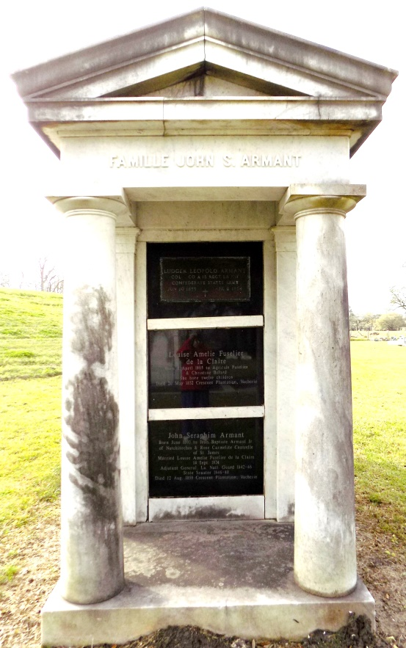 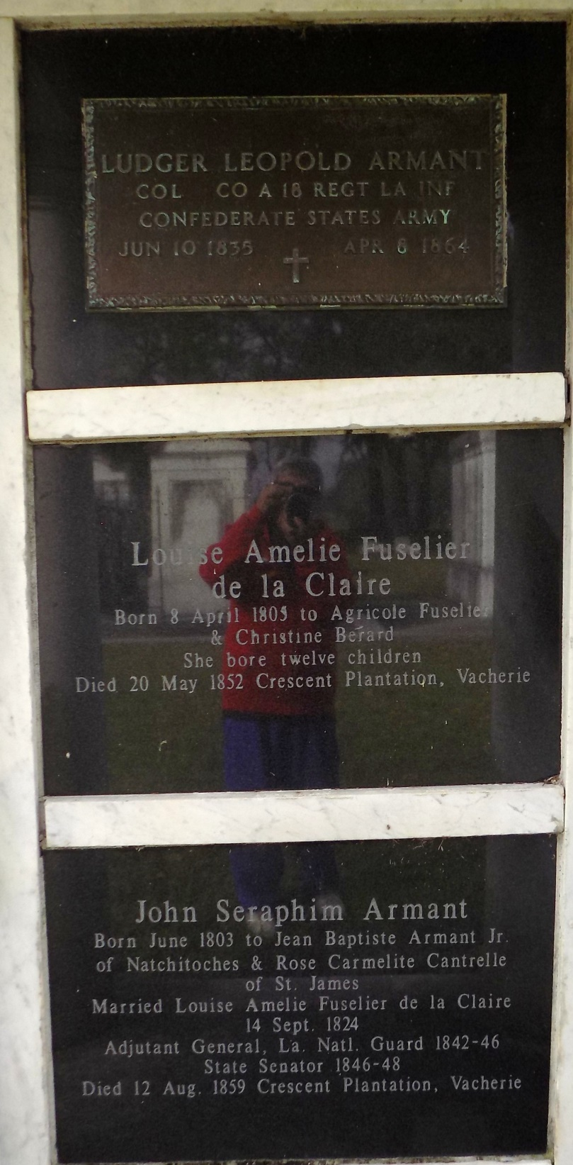

With his regiment situated on the extreme left of the line and under orders to hold back half of his men as a reserve, Colonel Armant nevertheless elected to lead the remaining half in the attack. Having advanced against the enemy position and endured a very heavy fire of artillery and musketry, Colonel Armant had his horse shot from under him. In that instant, noticing that his color bearer was down, Colonel Armant seized the standard and bore it forward. Although, desperately wounded moments later, he kept the colors aloft, and despite two additional wounds, maintained his post on the field. 'When last seen alive, he was prostrate, trying to hold up his flag…bidding defiance to his destroyers,' thus even unto death, providing his men with an extraordinary, inspirational example of heroic leadership."

Leopold Ludger Armant hailed from a family of military men. Great-grandfather John Marius Armant had commanded the Armant Brigade in the Revolutionary War. Grandfather John Baptist Armant had served Louisiana as brigadier general of the state militia and father John Scraphin Armant had commanded the state militia under Gov. Alexander Mouton, father of Gen. Alfred Mouton, his own divisional commander.

… It was four o'clock when Brig. Gen Alfred Mouton gave the signal to advance. At double quick, Armant's men … rushed into the open. Riding…. Col Armant guided their line down a slight slope…Halfway across, the infantry entered a deep ravine and started up the opposite side. … Cannon boomed…shells screamed overhead…But the Southern lines moved onward…emerging …with their formations intact. A volley of musketry smoked from the distant woods. … Minie balls bit the air like angry bees. … Confederates fell by the dozens yet the ranks closed *&* surged onward. … Amid the yells of his soldiers… Armant wheeled his mount to direct the battle line. … the animal stumbled- badly wounded - *&* dumped him …to the ground . Now his men could not see him! … The colors! Seeing the bearer fall Armant rushed … *&* grabbed the regimental flag, feeling in the same moment a powerful blow that knocked him to the ground… must keep the colors waving! Struggling … to keep the flag aloft, the gallant colonel was hit a second time. … his hands slippery with his own blood… he wrapped his arms *&* body about the staff… to keep the standard flying. … Then a third blow… he could not rise yet his men were all around him … his boys, Louisianians…

Col Leopold Ludger Armant was posthumously awarded the Confederate Medal of Honor. His decoration is on permanent public display in the Louisiana Historical Association's Memorial Hall Confederate Museum in New Orleans.

CONFEDERATE MEDAL OF HONOR CITATION For COLONEL LEOPOLD LUDGER ARMANT, 18th Louisiana Consolidated Regiment, C.S.A., Battle of Mansfield, Louisiana, 8 April 1864

Source: Valor in Gray by Gregg S. Clemmer  
Transcribed by Donna Meinscher Estes