Rose Carmelite (Cantrelle) Armant

August 7, 1936 – September 30, 2005

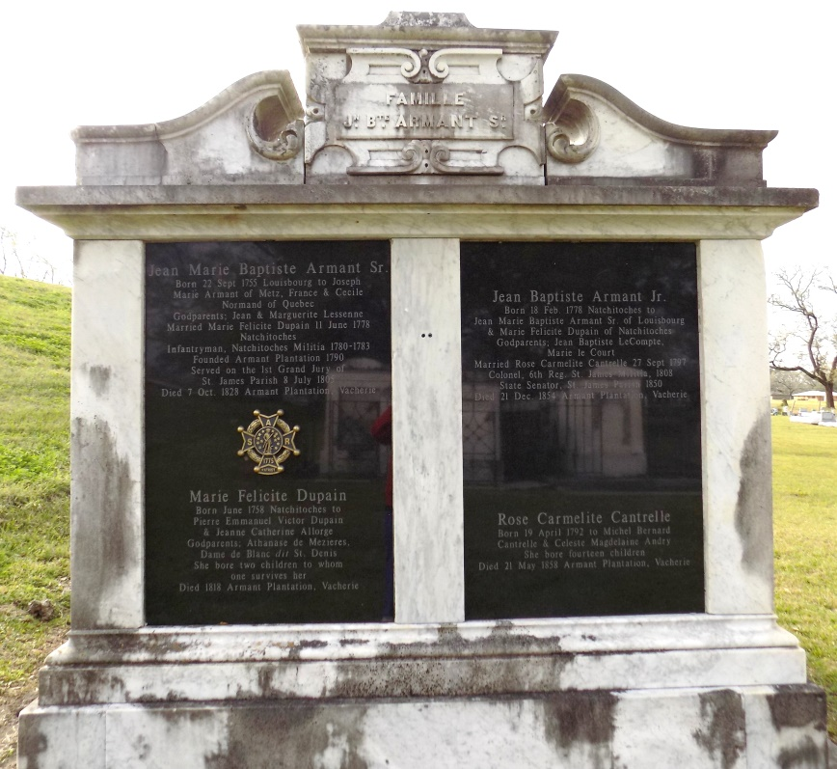

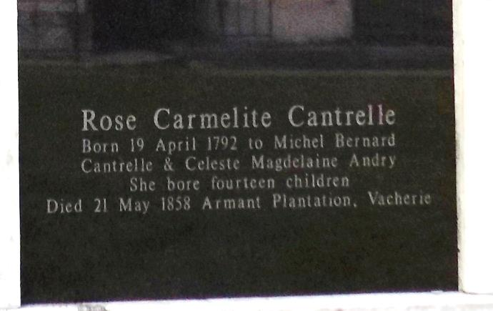

CANTRELLE, Rosa Carmelita (Miguel ***&*** Celestina ANDRY) m. 27 Sept. 1797, Juan Bautista ARMANT (Juan Maria Felicitas DUAIN of Natchitoches) wit: Pedro DUPAIN;***&*** Miguel CANTRELLE (SJA-2, 40)<br>

Diocese of Baton Rouge Catholic Church Records, Volume 2 pgs. 174 ***&*** 28

**

CANTRELLE, Rosa Carmelita (Miguel, omitted of St. James Parish, and Celeste ANDRY) bcs. 18 Oct. 1784, bt. previously, bn. 19 Apr. 1782, spo. Gilberto Antonio MAXENT, absent, proxy Maximilliano MAXENT and Maria Rosa ANDRY (SLC, B9, 341)

Archdiocese of New Orleans Sacramental Records, Volume 4, p. 48   
Both contributed by CBP