Violet (Herdzick) Bellow

November 26, 1931 – July 30, 2006

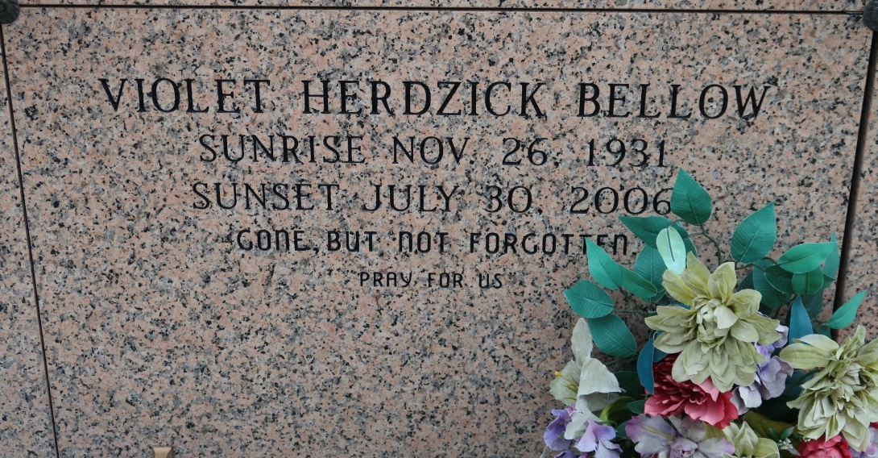

Violet H. Bellow, 74, a native and resident of Vacherie, died at 5:30 a.m.

Sunday, July 30, 2006.

Visitation will be from 8 a.m. to funeral time Tuesday at St. James Catholic

Church in Vacherie. Mass will be at 11 a.m. Tuesday at the church, with burial in the church cemetery.

She is survived by two sons, Jimmy Bellow and wife, Connie, and Kim Bellow and wife, Wanda; one daughter, Debra Bellow Rodrigue; one brother, Eli Herdzick; one sister-in-law, Lois B. LaCoste; six grandchildren; and six great-grandchildren.

She was preceded in death by her husband, Clyde J. Bellow; her parents, John and Mary Herdzick; one son-in-law, Edward J. Rodrigue; one brother, Mathew Herdzick; and two sisters, Wanda Weaver and Anne Karsko.

Landry's Funeral Home is in charge of arrangements.

The Houma Courier, Terrebonne Parish, LA

July 31. 2006

Contributed to usgwarchives.net by Louis Lavedan