Tessie (Hatfield) Bourgeois

May 6, 1923 – February 8, 2014

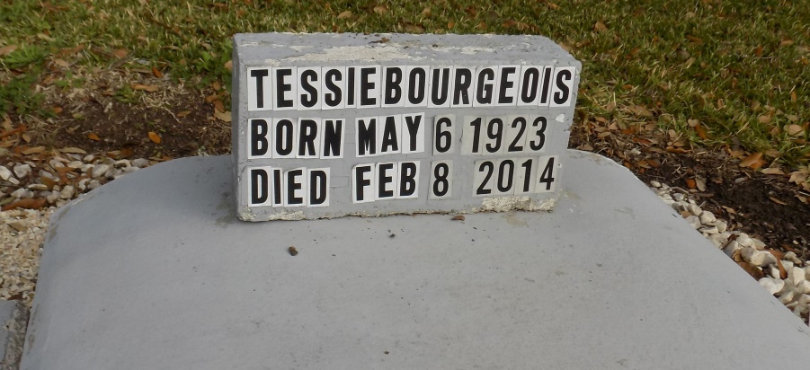

Tessie Hatfield Bourgeois, 90, a native of Texas and resident of St. James Parish, died Saturday, Feb. 8, 2014. She was born May 6, 1923 in Anderson, Texas.

Visitation will be from 9 a.m. until funeral time Thursday at St. James Catholic Church. A Mass of Christian burial will be at 11 a.m. Thursday at the church, with burial in the church cemetery.

She is survived by her children, Shirley and David Braun, Steve and Brenda Bourgeois, Glen and Cheryl Bourgeois, Linda and John Wells, Edmond and Barbara Bourgeois, Lucille Bourgeois, Thelma Bourgeois and Joe Cortez, and Jerry Bourgeois; 16 grandchildren; 21 great-grandchildren; and one great-great-grandchild.

She was preceded in death by her parents, Freddie and Sarah Pharris Hatfield; husband, Wilfred Bourgeois, who she married Oct. 9, 1943; children, Elaine, David, and Martin Bourgeois; and siblings, C.J., Willie, Wayne, Maggie, Dorothy, and Lillie.   
 She was a loving wife, mother, and grandmother who will be greatly missed by her family. Ourso Fuenral Home in Donaldsonville is in charge of arrangements.

Houma Today *&* The Daily Comet, Terrebonne Parish, LA

Feb. 11 to Feb. 12, 2014