Ellis Joseph Brossett

December 9, 1909 – November 9, 2009

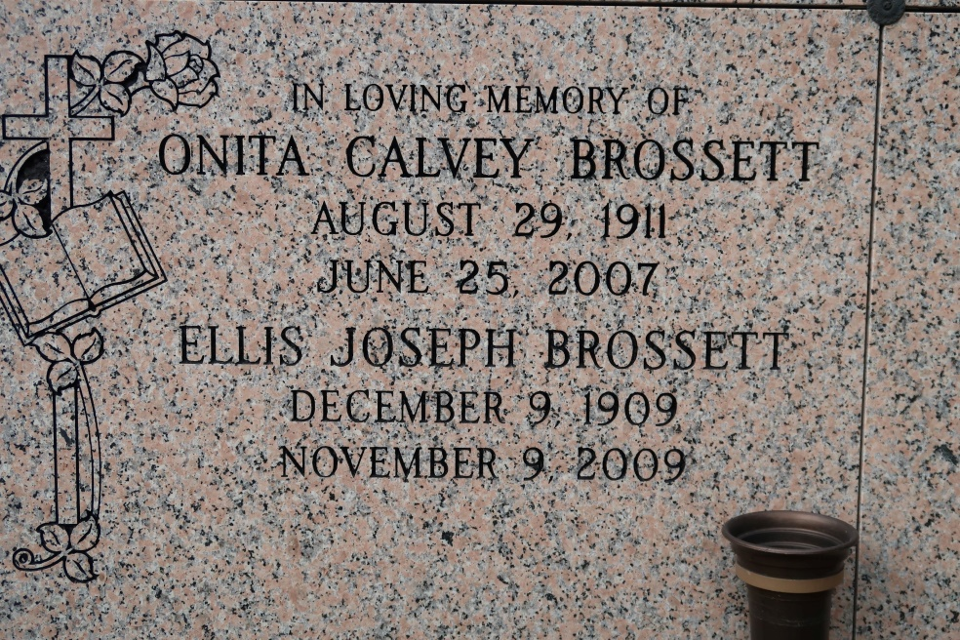

Ellis J. Brossett entered into eternal rest on November 9, 2009. Beloved husband of the late Onita C. Brossett. Father of Ellesia B. Irving, Chalita B. Robinson, Elery J. Brossett and the late Ellis M. Brossett, Sr. Father-in-law of Joyce B. Brossett and the late Albert D. Irving and Larry Robinson. Grandfather of 12. Great-grandfather of 10. Also survived by a host of nieces, nephews, cousins other relatives and friends.

Relatives and friends of the family are all invited to a Mass of Christian Burial on Saturday, November 14, 2009 at St. Catherine Drexel Catholic Church (formally Holy Ghost), 2015 Louisiana Ave., at 9:30 a.m. Interment will be in St. James Cemetery in St. James, La. Visitation will begin at 8:30 a.m. CHARBONNET-LABAT GLAPION, 581-4411.

The Times-Picayune, New Orleans, Louisiana

November 13, 2009