Onita (Calvey) Brossett

August 29, 1911 – June 25, 2007

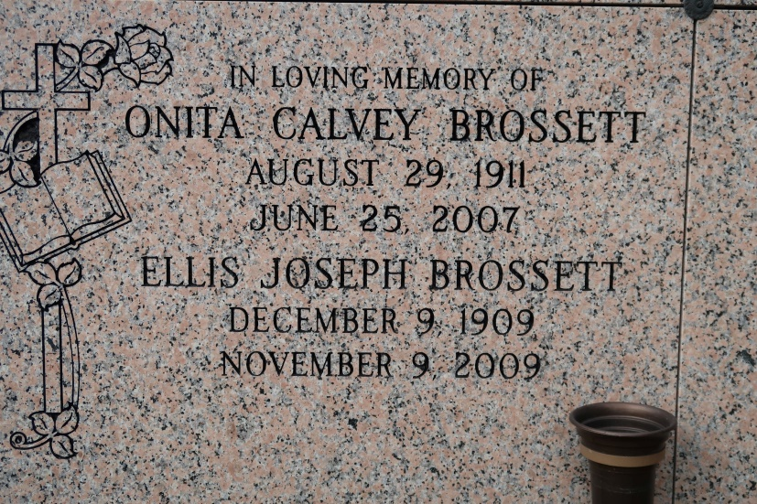

Onita Calvey Brossett entered into eternal rest on Monday, June 25, 2007 at the age of 95 years. She was a resident of New Orleans, La. until Hurricane Katrina returned her to the place of her birth, St. James, La., also the place of her death.

Beloved wife of Ellis J. Brossett who she was married to for 75 years. Mother of Ellesia Brossett Irving, Chalita Brossett Robinson, Elery Joseph Brossett, the late Ellis Matthew Brossett and infant daughter, Sandra Marie Brossett. Sister of Leona Calvey LeBeouf, Irma Calvey of St. James, La. and Lelia Calvey Dinvaut of Lucy, La. Survived by 12 grandchildren, 8 great grandchildren, nieces, nephews, cousins, and friends.

Onita was a devoted wife and homemaker. She was an active member of Holy Ghost Catholic Church since 1932 where she participated in various school and church activities. She was a member of St. David's Catholic Church Senior Citizens Group and Xavier University Ladies Auxillary. She will be sadly missed by all who knew her.

Relatives and friends of the family are invited to attend the Mass of Christian Burial of Saturday, June 30, 2007 at 11:00 a.m. from the St. James Catholic Church, 6613 Hwy. 18, St. James, La. 70086. Visitation at the church after 9:00 a.m. Recitation of the Rosary at 10:00 a.m. Entombment church mausoleum. THE BALONEY FUNERAL HOME LLC. 399 Earl Baloney Dr., Garyville, La. 70051 Information: (985) 535-2540 In charge of arrangements.

The Times-Picayune, New Orleans, Louisiana

June 29, 2007