William John Bull Sr.

April 18, 1942 – February 14, 2020

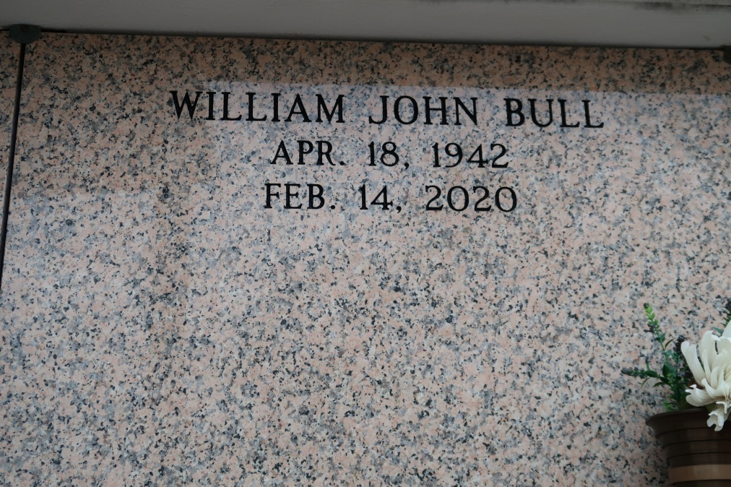

William John "Johnny" Bull, Sr., 77, passed away peacefully on February 14, 2020 at the Baton Rouge General Mid City "Butterfly wing", after a battle with cancer.

He was born April 18, 1942 in New Orleans, son of Henry Bull and Julia (Spillers) Bull Campbell. Johnny graduated from Fortier High School in 1960. Following graduation, he attended LSU, Southeastern LA University and Tulane prior to joining the US Marine Corps Reserves – years filled with adventure that generated many of the good stories he frequently shared. In 1964, his mom introduced him to a "sweet young nursing student", Karolyn Ann (Kitty) Zeringue, and they were married in 1966, celebrating their 54th wedding anniversary just last week.

Johnny is survived by his wife, Kitty; his daughter, Michele Shaffer (Russel); two sons, Dr. William John Bull Jr., (Monika) and Shawn Bull (Michelle); sister, Aline (Bull) Wetta Cunningham; four grandchildren, Joe Galas, Johnny Bull, Alex Bull and Julia Shaffer. He was preceded in death by his parents; brother-in-law and best friend, Thomas J. Wetta III. He has been blessed with many beloved nieces, nephews and cousins.

He enjoyed many years working in the Dredging industry and was proud of the many beach projects he helped rebuild. He retired from Dredging Supply Company in 2013, where he frequently declared that his favorite part of the job was "uncle" since he felt honored to work with nephews Bill and Bob Wetta. While his wife and children were his greatest pride and joy, he also loved being in nature, hunting & fishing as much as possible. His favorite fishing partner was his sister Aline, even though she always caught more fish than him!

A memorial service celebrating Johnny's life will be held on Monday, February 17, 2020 at 10:30 am at Our Lady of Mercy Catholic Church in Baton Rouge. Visitation will start at 9:30 am prior to the mass service. A private interment will occur at a future date. Memorial contributions can be made to the [charity of your choice](http://www.legacy.com/obituaries/theadvocate/condolences-charities.aspx?keyword=coycalz&pid=195420751) or Johnny's admired charity, [St. Jude Children's Research Hospital](https://www.stjude.org/donate/legacy.html?frequency_selected=2&legacypid=195420751&memoryFirstName=William&memoryLastName=Bull) ([www.stjude.org](http://www.stjude.org/)). Prayers are always appreciated. Ourso Funeral Home of Gonzales is in charge of arrangement.

The Advocate, Baton Rouge, Louisiana

February 15 - 17, 2020