Ivy Joseph Bye

August 11, 1925 – January 15, 2019

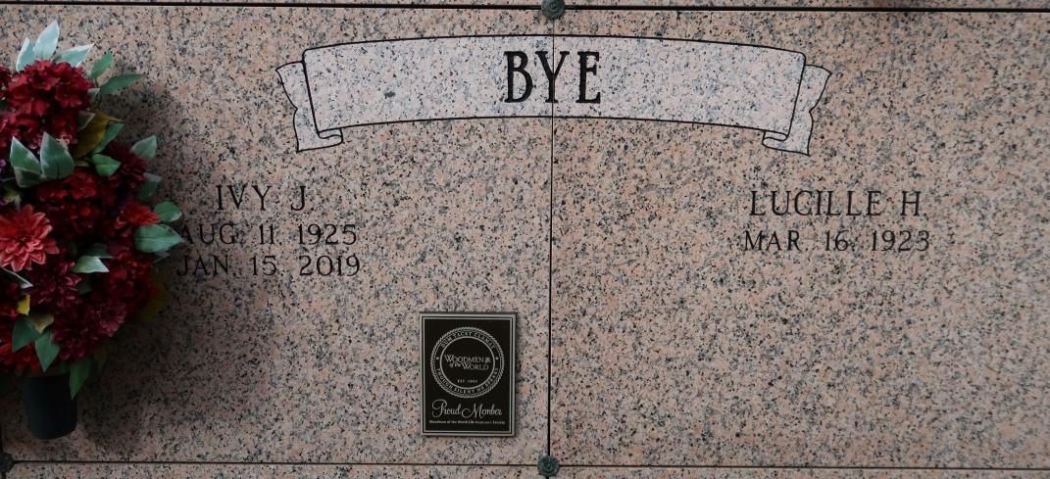

Ivy Joseph Bye, 93, a native of Vacherie and resident of St. James, passed away on Tuesday, Jan. 15, 2019.  
 Ivy was a loving husband, father, grandfather, great-grandfather, brother and friend. He was a Sugar Cane farmer (Waguespack Farm) for 70 plus years. Ivy was an avid gardener who enjoyed playing music and having many Thursday night "suppers" at the camp. He served as the former President of Woodmen of the World Camp 494 and enjoyed cooking jambalaya for everyone to enjoy.  
 He leaves behind to cherish his memory, his wife of 73 years, Lucille Hymel Bye; daughter, Barbara (Eugene "Tunny") Chauvin; five grandchildren, Leslie (Chris) Kimble, Rae Lynne (Casey) Amedee, Danielle Chauvin, and Shelly Bye and Dean (Jennifer) Bye; five great-grandchildren, Holden and Lily Amedee, Abigail and Harrison Kimble, and Caleb Bye; and two sisters, Girlie Berthelot and Lillian (Lloyd) Hymel.  
 He was preceded in death by his son, Gary (Connie) Bye; parents, Wilfred and Lucile "Memere" Bye; eight siblings, Verna Amedee, Leonce Bye, Wilfred Bye, Lucille Tregre, Donald Bye, Therese Bye, Uranie "Pete" Waguespack and Damase Bye.  
 The family would like to thank Heart of Hospice and his caregivers, Cheryl Lemar, Shanika Junior and Jarielle Mckinnis for taking excellent care of Ivy.  
 Visitation will be held from 9 a.m. until Mass of Christian Burial at 11 a.m. on Saturday, Jan. 19, at St. James Catholic Church in St. James. Interment to follow in the church mausoleum.  
 In lieu of flowers, donations can be made to [St. Jude Children's Research Hospital](https://www.stjude.org/donate/legacy.html?frequency_selected=2&legacypid=191290493&memoryFirstName=Ivy&memoryLastName=Bye).

Houma Today, Terrebonne Parish, Louisiana

January 17 - 18, 2019