Shirley Mae (Ellison) Cantrelle

November 10, 1928 – May 11, 2019

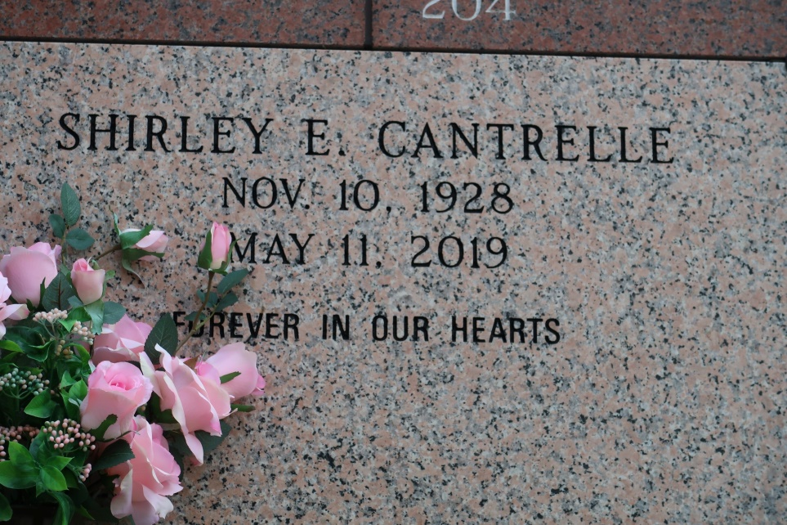

Shirley Mae Ellison Cantrelle passed away peacefully on Saturday, May 11, 2019, at 11:08 a.m. at St. Elizabeth Hospital in Gonzales, LA. She was 90 years old.

Shirley was born on November 10, 1928 in New Orleans, LA and reared by her grandmother, Josephine Overton Raymond, her mother Velma Parker Green and stepfather Royal Sam Green. She married Paul Cantrelle Jr in 1948 and raised seven children in St. James, LA.

She obtained a BS in Elementary Education from Southern University and A&M College in 1965 and enjoyed a 31-year career as an educator in the St. James Parish School System. She was longtime parishioner of St. James Catholic Church where she was named Director of Religious Education. She also served as a member of the Knights of Peter Claver Ladies Auxiliary. She leaves to cherish her memories, siblings – The Joseph and Ellison Families; four children: Janice Cantrelle Kelson of Donaldsonville, Velma Adrienne Ferchaud (Dwight) of Gonzales, LA, Christopher Cantrelle of Garland, Tx, and Anthony Cantrelle of St. James; one godson, Ralph Williams (Olivia) of Denham Springs, LA; twenty-four grandchildren, thirty-two great-grandchildren, three great-great-grandchildren, daughters-in-law: Ann, Sheryl, Ava, Marsha, Darlene & Shawanda; and a host of nieces, nephews, other relatives and friends.

In addition to her grandmother, mother, father and husband, she is preceded in death by three sons: Daryl, Michael, and Paul III Cantrelle; two sons-in-law, Walter Celestin & Harvey Kelson Jr; and one grandson Jaime Peterson.

Mass of Christian burial will be held on Saturday, May 18, 2019, from St. James Catholic Church, 6613 LA-18, St. James, LA, Father Matthew McCaughey, celebrant. Visitation will begin at 8:30 a.m. followed by Rosary then service at 11:00am. Entombment, church cemetery. Treasures of Life Funeral Services have been entrusted with her final care. 315 E. Airline Hwy, Gramercy, LA.

The Advocate, New Orleans, Louisiana

May 15 - 18, 2019