Bill Joseph Champagne

December 18, 1944 – February 18, 2020

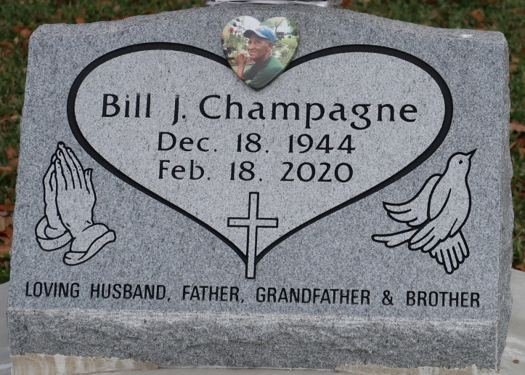

The Lord is my shepherd; I shall not want. He maketh me to lie down in green pastures: he leadeth me beside the still waters." Psalm 23: 1-2.

On Tuesday, February 18, 2020, Bill Champagne heard a voice saying come take your rest, your job on earth is done. He was 75 years old. Bill was the eldest child born to Mable Carter. He was raised on Bessie K with his younger brother, later on Bill and his family moved to Baytree. Bill was married to Ethyl Mae Isom for 45 years. He was a hard worker for Graugnard Farm for many years.

Bill leaves to share his memory his wife Ethyl Mae, five children Blair Favorite of Atlanta, GA, Lisa Isom (Wilbert) of New Orleans, LA, Gary Lewis (Carmen) of Reserve, LA, Wanda Isom (Michael) of Gonzales, LA, and Elroy Isom (Angelic), fourteen grandchildren, twenty-two great-grandchildren, one brother Eunice Carter, one godchild Renate Sterling Boudin, six sisters-in-laws, a host of nieces, nephews, relatives and friends.   
 Bill is preceded in death by his mother Mable Carter, stepfather Eunice Carter, Sr., his father-in-law and mother-in-law, aunts, uncles and cousins. A mass of Christian burial will be held on Friday, February 28, 2020, at Saint James Catholic Church 6613 LA-18, St. James, LA 70086 at 11:00 am. Visitation will begin at 9:00 am.   
 Interment at Saint James Catholic Church Cemetery.

Treasures of Life Center for Funeral Services, St. James Parish, LA

August 17, 2020