Harold James Chiquet Jr.

July 31, 1936 – March 24, 2011

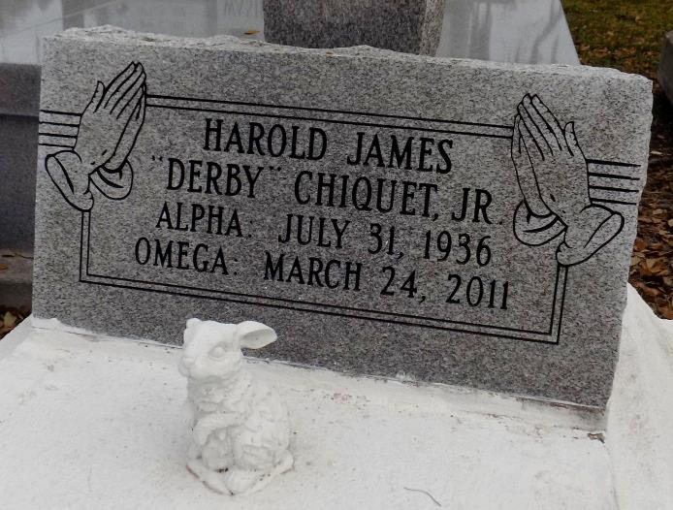

Harold James Chiquet, Jr. was born July 31, 1936 in Saint James, Louisiana to the parentage of Selina and Harold Chiquet, Sr. He departed this life while hospitalized in Baton Rouge, Louisiana.

Harold began his life's journey in the community of Saint James, Louisiana. He received his first communion and was catechized and practiced his faith in the Lord Jesus as a faithful Catholic at the St. James Catholic Church in St. James, Louisiana. He enjoyed the spiritual influences of mass and was faithful in the usher's ministry. His life reflected a determination of being faithful to the teachings of the Church. He was educated in the St. James Public Schools. He began his pilgrimage toward independence and self-sufficiency as he entered the work force at an early age. He was employed by Falgoust Farms and St. James Sugar Co-op. He retired from Triad Nitrogen following twenty-nine years of dedicated service.

He was married to Rena Tennessee. To their union two children were born. Following the dissolution of this union, Harold married Sedonia Celestin of Vacherie, with whom he celebrated fifteen years of loving marriage. To their union one daughter was born.

Harold was preceded in death by his parents Selina and Harold James Chiquet, Sr.; two sisters, Jacqueline Robinson and Eula Mae Brown and one brother, Jacob Rodney. He leaves to mourn his passing and to cherish his fond memories his wife, Sedonia Chiquet; three daughters, Giavonia Celestin of Vacherie, Selina Chiquet and Kim Allen of Donaldsonville, Louisiana; two sons, Harold James Chiquet III and Brian Kwendall Allen (Stacy); three step-daughters, Shawan Celestin, Erica Celestin Robertson (Nolan), and Caroline Henderson; one brother, Raymond Earl Spencer of Riverside, California; fifteen grandchildren and three great-grandchildren. He is also survived by four aunts, one uncle, three nieces, two nephews, five sisters-in-law, seven brothers-in-law, and two devoted friends, Lloyd Edwards and Lawrence Breaux.

Harold leaves a legacy of being a "good" person. He was a "good" husband, a "good" father, a "good" citizen, a "good" neighbor and a "good" friend. There are many other significant aspects of his life that cannot be contained in this brief portrait, but these are recorded to leave the indelible imprints in our hearts and minds that Harold James "Derby" Chiquet, Jr. was a "good" man who lived in the community of our lives.

Service will be held on Wednesday, March 30, 2011 at St. James Catholic Church, 6613 Hwy. 18, Vacherie, Louisiana, at 11:00 a.m. Visitation will be at 9:00 a.m. until the time of service. Father Louis Oubre, officiating. Burial will be held in the church cemetery. Arrangements by The Baloney Funeral Home, LLC, 399 Earl Baloney Street, Garyville, Louisiana 70051, (985) 535-2540. Guests may sign the register at [www.baloneyfuneralhome.com](http://www.baloneyfuneralhome.com/).

The Times-Picayune, New Orleans, Louisiana

March 29, 2011