Helena (Caire) Cox

January 27, 1909 – April 29, 2005

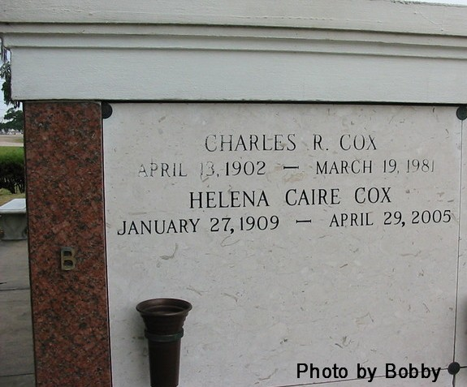

Helena Caire Cox was born January 27, 1909 at Oak Alley Plantation in St James Parish. She died, Friday. April 29, 2005 at 1:00 A.M. at Thibodaux Regional Medical Center. She was 96 years old.

Preceded in death by her parents, Jean B. and Irma Simon Caire, one son, John Francis Cox, her husband Charles R. Cox, two brothers, Guy and Louis Caire of St James and one sister, Mae Caire King of St James.

Survived by her step son, C. P. Cox and wife, Leanne of Dubuque, Iowa; granddaughter, Cynthia Cox Farland and husband Eric, and great granddaughter, Bodin Thorland of Rochester, MN. Also survived by her niece, Elaine Caire Allee and husband, Lee of St James who she lived with for fourteen years, grand nieces and nephew are: Mary Lee Allen of Thibodaux, Elizabeth Johnston of Baton Rouge, Julie Dardeau and Stacy Allee of Praireville, LA. Also there are 14 great grand nieces and nephews.

Helena was a retired St. James Parish School teacher of some 30 years. She graduated from Southwest University in Lafayette. She taught English and French for many years and taught elementary school at St. James High School. She got her lower education from Cypress Grove Elementary and went on to the new St. James High School when it was first built.

Visitation will commence Monday, May 2, 2005 at St. James Catholic Church, St. James, LA from 10:00 AM until Mass of Christian Burial at 12:00 noon. Rev. Louis Oubre - officiating. Entombment will be in the church Mausoleum. Arrangements entrusted with OURSO FUNERAL HOME of Donaldsonville, LA.

The Times-Picayune, New Orleans, Louisiana

April 30 - May 1, 2005