Eloise (Richard) Falgoust

September 26, 1934 – February 20, 2009

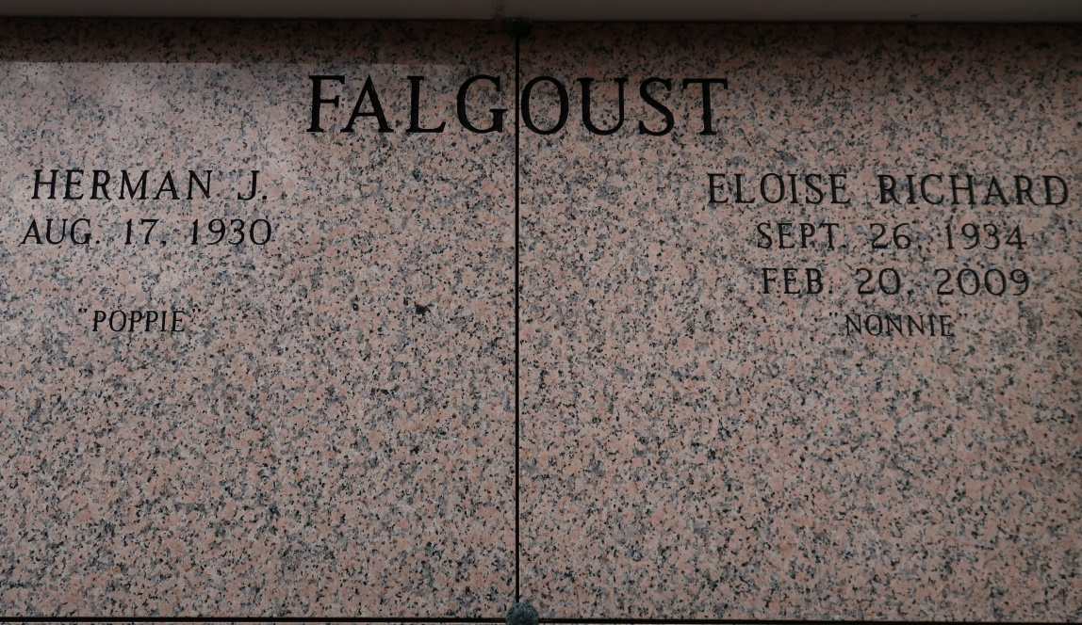

Eloise R. Falgoust, 74, a native of Paincourtville and resident of St. James, died after a long battle with cancer on Friday, Feb. 20, 2009. Visitation will be from 1 p.m. to funeral time Monday at St. James Catholic Church. Mass will be at 3 p.m. Monday at the church, with burial in the church cemetery.  
She is survived by her husband of 56 years, Herman J. Falgoust; children, David M. Falgoust and wife, Sarah, of Atlanta, Dr. Susan F. Puyau and husband, Dr. Michael, of Baton Rouge, Paul N. Falgoust and wife, Wendy, of Thibodaux, and Sybil F. Marcello and husband, Frank, of Donaldsonville; sisters, Mildred R. Blanchard, Adeline R. Simon, Mary Ann R. Simon and Lorain R. Cazenave; and nine grandchildren. She was preceded in death by her parents, Taylor J. Richard and Angele S. Richard; brothers, Herman, Milton and Robert Richard; and one sister, Eula Mae R. Blanchard. In lieu of flowers, memorial donations can be made to a charity of choice. Ourso Funeral Home is in charge of arrangements.

Unknown source

\*\*\*\*\*

A resident of St. James, Eloise R. Falgoust died on Friday, Feb. 20, 2009, after a long battle with cancer. A native of Paincourtville, she was born on Sept. 26, 1934. Survived by her husband of 56 years, Herman J. Falgoust; children, David M. Falgoust and wife Sarah M. Falgoust, of Atlanta, Dr. Susan F. Puyau and husband Dr. Michael Puyau, of Baton Rouge, Paul N. Falgoust and wife Wendy R. Falgoust, of Thibodaux, and Sybil F. Marcello and husband Frank P. Marcello, of Donaldsonville. She is also survived by nine grandchildren; sisters, Mildred R. Blanchard, Adeline R. Simon, Mary Ann R. Simon and Lorain R. Cazenave.

Preceded in death by her parents, Taylor J. and Angele S. Richard; brothers, Herman, Milton and Robert Richard; and sister, Eula Mae R. Blanchard.

Visitation at St. James Catholic Church, St. James, on Monday, Feb. 23, from 1 p.m. until Mass of Christian Burial at 3 p.m.   
 Interment at St. James Cemetery. In lieu of flowers, memorial donations may be made to a charity of choice.

The Advocate, Baton Rouge, LA

Sunday, February 22, 2009  
Contributed by Jane Edson