Wilson Joseph Favorite Sr.

September 20, 1920 – April 9, 2002

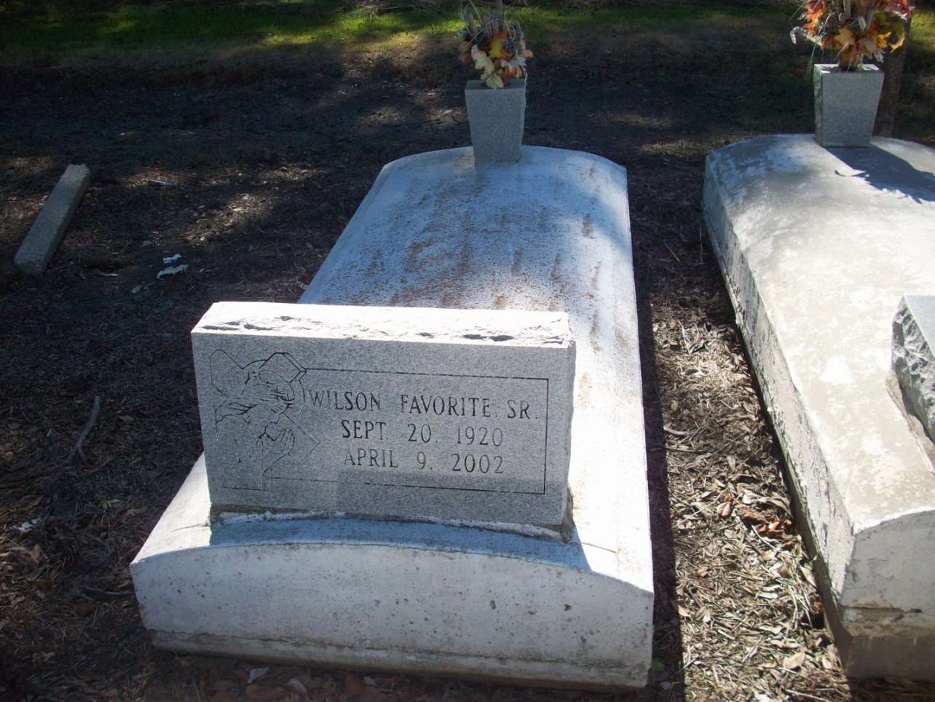

Photo by TMB

Wilson Joseph Favorite Sr., 81, a native and resident of Vacherie, died April 9. He was the husband of Bertha Louise Pierre Favorite and father of Juliette Jasper and Kathleen, Marrie, Wilson Jr., James and Anthony Favorite. He was also the son of the late Joseph and Virginia Lemieux Favorite and brother of the late Harold Favorite Sr. He is also survived by 17 grandchildren and four great-grandchildren.

Unknown source

\*\*\*\*\*

Wilson Joseph Favorite, Sr. of Vacherie, LA on Tuesday, April 9, 2002 at Charity Hospital in New Orleans. Son of the late Joseph and Virginia Lemieux Favorite. Husband of Bertha Louise Pierre Favorite. Father of Wilson Joseph, Jr., James Donald, Anthony Ray, Kathleen Mary Favorite and Juliette Favorite Jasper all of Vacherie, LA, Marrie Rose Ann Favorite of New Orleans, LA. Father-in-law of Elaine, Terese, Valerie Favorite, Angelios Washington, Sr. and Craig Jasper. Brother of the late Harold Favorite, Sr. Also survived by 17 grandchildren, 4 great grandchildren, 2 aunts, a host of nieces, nephews, sisters and brothers-in-law, cousins and friends. Devoted family friend of Agnes Blaine Washington. A native and resident of Vacherie, LA. Age 81 years.

Relatives and friends of the family, also priest and parishioners of St. James Catholic Church in St. James, LA and neighboring churches; employees of Waterford III, Wyndotte, Rose's Catering, SRF Group; members of Baytree Benevolent Society are invited to attend a Mass of Christain Burial on Friday, April 12, 2002 at 11:00 A.M. fro the St. James Catholic Church in St. James, LA. Father Louis Oubre, celebrant. Interment church cemetery. Visitation at the church after 8:00 A.M. on Friday. Recitation of the Rosary at 9:30 A.M. THE BALONEY FUNERAL HOME In Charge of Arrangements

Times-Picayune, New Orleans, LA

Thursday, April 11, 2002  
Contributed by Jane Edson