Alonzo Peter Fefie

February 14, 1914 – January 10, 2003

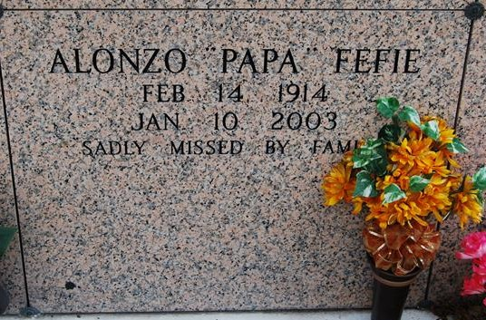

Alonzo Peter "PaPa" Fefie, a retired heavy equipment operator for St. James Parish, died Jan. 10 at Prevost Memorial Hospital in Donaldsonville. He was 88. Mr. Fefie was born in Vacherie and lived in St. James for the past 63 years. He was a member of Lil' Hat of Vacherie and the Pride of Brookstown of St. James.

Survivors include two sons, Cleveland Fefie of Donaldsonville and Joseph Fefie; nine daughters, Mary Fefie of New Orleans, Doris Truehill of Labadieville, Theresa Zenon of Hawthorne, Calif., Annette Spurlock of Donaldsonville, Marilyn Sutherland, Antoinette Simmons, Betty Jones and Rita and Odette Fefie; 25 grandchildren; 25 great-grandchildren; and three great-great-grandchildren.

A Mass will be said today at 11 a.m. at St. James Catholic Church, 6613 Louisiana 18, St. James. Visitation will begin at 9 a.m., with recitation of the rosary at 10:30 a.m. Burial will be in the church mausoleum. Demby ***&*** Son Funeral Home is in charge of arrangements.

Times Picayune, New Orleans, LA

Saturday, January 18, 2003  
Contributed by Jane Edson