Beulah Marie (Johnson) Ficher
September 1, 1944 – October 8, 2021

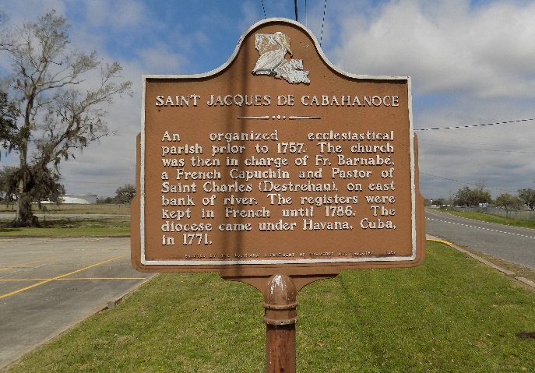

Beulah Marie Ficher, 77 years old, was born on September 1, 1944 to the union of the late Eddie Sr. and Elvie Johnson in St. James, Louisiana. On Friday, October 8, 2021, Beulah was called home to be our Lord and Savior Jesus Christ.
Beulah went to Magnolia High School and moved to New Orleans, LA in 1968 where she became a Home Health Care Aid. She resided in New Orleans, LA until 2005 and moved to Houston, TX until her passing to be with our Lord and Savior Jesus Christ.
Beulah was an active member of Kingdom Church in Houston, TX, where she was baptized on September 1, 2013 by Pastor Rondy Long. She was an active member and one of the oldest members of the church up until her last days before she went to be with our Lord and Savior Jesus Christ. She enjoyed going to the church every Sunday, bible study and participating in the church activities. She was loved by her pastor and church members.
Beulah was loved by her children, grandchildren, family and friends. She especially enjoyed spending time with her grandchildren. While residing in New Orleans, Beulah was an active member within the community and volunteered for various programs. She was a fun, generous and kind person who loved everyone. She loved to cook for her family and friends. She was out spoken and loved to share stories of her upbringing. One of her favorite things to do was traveling with her daughter and grandchildren and she loved visiting Disney World and Universal Studios.
We all loved Beulah, but God loved her best. Loving memories will be cherished by her children; Charlene Ficher, Charles Ficher, Yolanda Fisher and Alastair Penn; her grandchildren, Gabrielle M. Ficher, Charles Ficher Jr, Raekwon R. Johnson, Whittley Ficher, Dalia K. Harris and Selassie Ficher. Beulah’s siblings; Annette Brown, Mary Jane Oppong, Mary Pakogoe, Natlean Harleax, Ann Louise Riley, Paul Johnson, Catherine Whittington, Nathaniel Johnson, Lester Johnson, Marie Fatherie, Raymond Johnson and Anthony Johnson; a host of relatives, nieces, nephews and friends. Beulah was preceded in death by her parents, Eddie Sr and Elvie Johnson, brothers Eddie Johnson Jr, Junius Johnson, Leroy Johnson, Andrew Johnson and sister Helen Johnson.
Relatives and friends of the family, Pastor, Officers and members of Mt. Calvary Baptist Church are invited to attend funeral service on Saturday, October 23, 2021 at 11:00 a.m. at Mt Calvary Baptist Church 8103 Mt. Calvary Street, St. James, LA 70086. In accordance with the CDC guidelines for COVID-19 all in attendance must wear a mask and practice social distancing. Interment at St. James Catholic Church Cemetery. Visitation at the above named church at 9:00 a.m. until service time.

The Patrick H. Sanders Funeral Home, LaPlace, Louisiana

