Antoine Royley Folse Sr.

September 27, 1914 – February 26, 2005

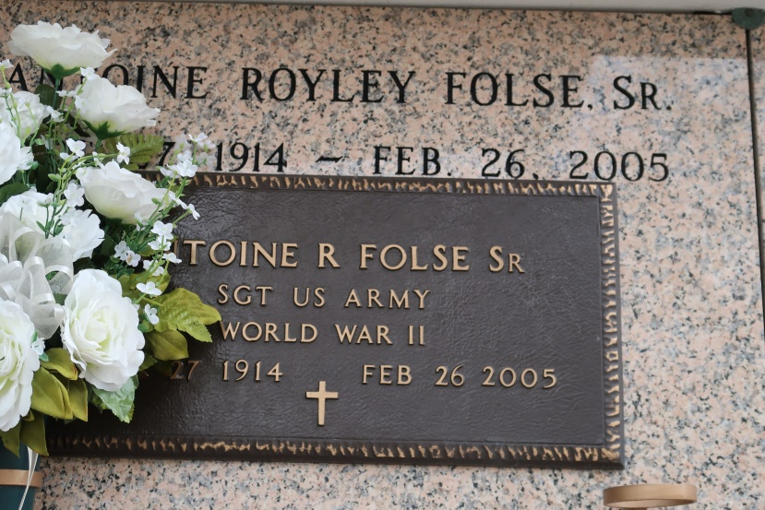

A retired superintendent at St. James Sugar Co-Op and a resident of Donaldsonville, he was entrusted to God's care on Saturday, Feb. 26, 2005, at Our Lady of the Lake Regional Medical Center. He was 90 and a native of Vacherie. He was a U.S. Army veteran having served in World War II in the 16th Cavalry Division, Troop C, under the command of Gen. Patton in the Battle of the Bulge.

Visiting at Ourso Funeral Home, Donaldsonville, Monday, Feb. 28, from 6 p.m. to 9 p.m. Visiting at St. James Catholic Church, St. James, from 8:30 a.m. until Mass of Christian Burial at 11 a.m., Tuesday, March 1, celebrated by the Rev. Louis Oubre and concelebrated by the Rev. Randy Cuevas. Entombment in church mausoleum.

He is survived by six sons and daughters-in-law, Royley Jr. and Theresa C. Folse, St. James, Chef John Folse and wife Laulie B. Folse, Gonzales, Jerry J. and Julie P. Folse, LaPlace, Lawrence "Larry" and Kathy I. Folse, Vacherie, Carroll "Tottie" and Elise R. Folse, Vacherie, and Philip J. and Theresa L. Folse, Gloucester, Mass.; two daughters and sons-in-law, Ruth Folse Hirsh and Dr. Michel, Donaldsonville, and Phyllis Folse Graves and John, Ocean Springs, Miss.; 19 precious grandchildren and 34 great-grandchildren.

He is preceded in death by his loving wife, Thérése Zeringue Folse; his parents, Louisey A. Folse and Lutetia Marse Folse; three sisters, Beatrice Matherne, Aurelise Becnel and Elodia Stein; a brother, Aureaus "Mac" Folse; an infant daughter, Faye Folse; and an infant son, Royley Folse III; and infant granddaughter, Mary Ann Schexnayder.  
NOTE: Therese Marie Zeringue Folse died 11 May 1955 at 37 yrs in St James parish. Burial unknown at this time.

Unknown source  
Contributed by Debbie G. Morrogh

\*\*\*\*\*

A retired superintendent at St. James Sugar Co-Op and a resident of Donaldsonville, he was entrusted to God's care on Saturday, Feb. 26, 2005, at Our Lady of the Lake Regional Medical Center. He was 90 and a native of Vacherie. He was a U.S. Army veteran of World War II.

Visiting at Ourso Funeral Home, Donaldsonville, Monday, Feb. 28, from 6 p.m. to 9 p.m. Visiting at St. James Catholic Church, St. James, from 8:30 a.m. until Mass of Christian Burial at 11 a.m., Tuesday, March 1, celebrated by the Rev. Louis Oubre and concelebrated by the Rev. Randy Cuevas and the Rev. Phil Spano. Entombment in church mausoleum.

He is survived by six sons and daughters-in-law, Royley Jr. and Theresa C. Folse, St. James, chef John Folse and wife Laulie B., Gonzales, Jerry J. and Julie P. Folse, LaPlace, Lawrence "Larry" and Kathy I. Folse, Vacherie, Carroll "Tottie" and Elise R. Folse, Vacherie, and Philip J. and Theresa L. Folse, Gloucester, Mass.; two daughters and sons-in-law, Ruth Folse Hirsh and Dr. Michel, Donaldsonville, and Phyllis Folse Graves and John, Ocean Springs, Miss.; 19 precious grandchildren and 34 great-grandchildren. He is preceded in death by his loving wife, Therese Zeringue Folse; his parents, Louisey A. Folse and Lutetia Marse Folse; three sisters, Beatrice Matherne, Aurelise Becnel and Elodia Stein; a brother, Aureaus "Mac" Folse; an infant daughter, Faye Folse; and an infant son, Royley Folse III.

Advocate, The (Baton Rouge, LA)

Sunday, February 27, 2005  
Contributed by Jane Edson