Gustave Geason

November 16, 1920 – February 20, 1986

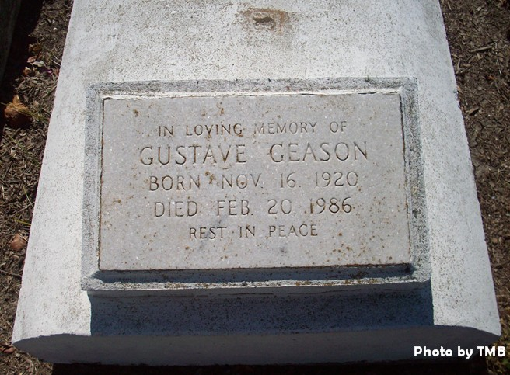

Died 12:20 p.m. Thursday, Feb. 20, 1986, at Ochsner Foundation Hospital, New Orleans. He was 65, a native and resident of St. James.

Survived by mother, Mrs. Viola Joseph Geason; a son, Paul Geason; a daughter, Sueown Whittington; two sisters, Mrs. Pearl Trudeau and Mrs. Annie Mae Harris;a brother, Joseph Geason, all of St. James; a grandson, Shean Geason, Clinton, Md.

Unknown source