Janel (Winchester) Gordon

June 16, 1957 – February 8, 2016

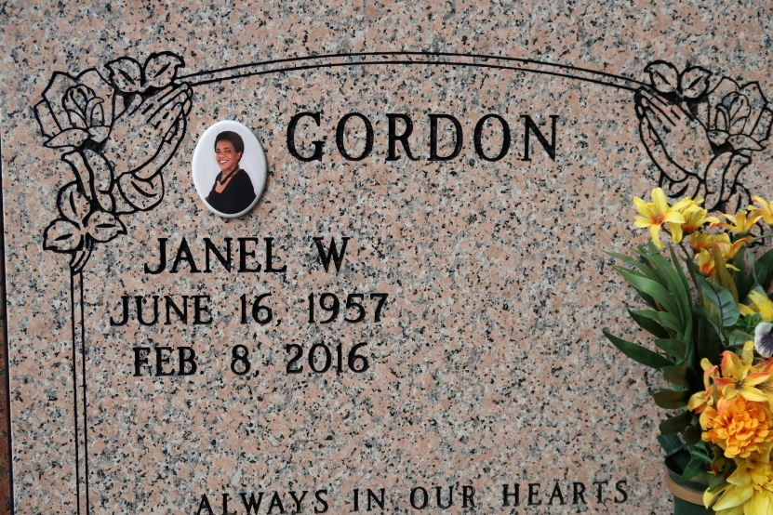

Janel Winchester Gordon, transitioned from her earthly home to her heavenly home in glory on February 8, 2016, age 58 yrs. Daughter of the late John Winchester and Mary Whittington Winchester. Wife of Kevin Michael Gordon, Sr. Mother of Markita L. and Kevin M. Gordon, Jr. (Joi). She reared her nephew, Quintell Winchester. Sister of Sylvia W. Tankerson, New Orleans, La, Florence Winchester of Houston, TX. Yolanda A. Winchester (Joseph) of St. James, John Winchester, Sr. (Mary), Donaldsonville, Sylvester Winchester, Sr. (Norma), Alcus Winchester, Sr. of St. James, Charles Winchester (Linda) New Orleans, Paul Winchester (Chelsea) of Minneapolis, MN., Joseph Winchester (Alberta) Baton Rouge and David Winchester (Adrence) Vacherie. Also survived by sisters and brothers-in-law, nieces, nephews, cousins, friends, aunts, and one uncle.

Janel was a faithful and dedicated member of St. James Catholic Church-Director of Religious Education at St. James and St. Philip Catholic Church.

Relatives and friends of the family, also priest and parishioners of St. James Catholic Church, neighboring churches, St. James High School Class of 1975 are invited to attend a mass of Christian burial on Mon. Feb. 15, 2016 at 11:00am from the St. James Catholic Church, 6613 Hwy 18, St. James, LA. Father Christopher Decker, Pastor, Father Maurice Nutt, Celebrant. Visitation at the church after 9:00am. Entombment at the church mausoleum. Treasures of Life, Center for Life Funeral Services entrusted with final disposition. 315 E. Airline Hwy, Gramercy, LA 70052.

The Advocate, Baton Rouge, Louisiana

February 13, 2016