Larry A. Granier

May 4, 1941 – August 24, 2011

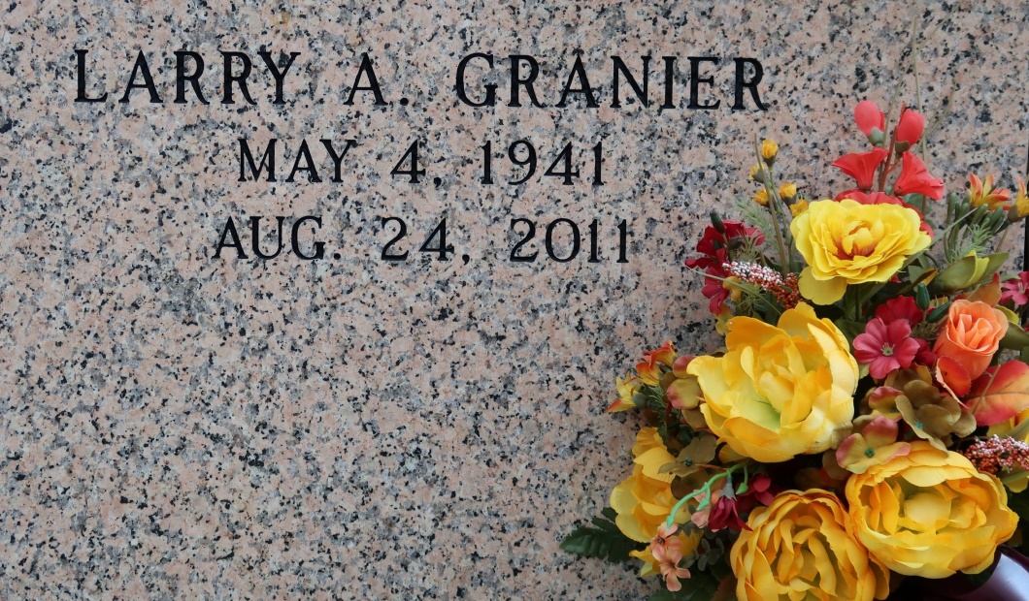

Larry A. Granier, 70, a native and resident of St. James, Passed away Wednesday, Aug. 24, 2011. He is survived by a sister, Mary Ann Granier Lambert; and three brothers, Thomas, Robert, and Timothey Granier.

Preceded in death by his parents, Louis and Edna Granier; and thre brothers, Earl, Raymond and Eugene Granier.

Visitation at St. James Catholic Church on Saturday, Aug. 27, from 8 a.m. until Mass of Christian Burial at 11 a.m. Entombment in the church mausoleum. Condolences can be made at [www.oursodonaldsonville.com](http://www.oursodonaldsonville.com).

The Advocate, Baton Rouge, LA

August 2, 2011