Carolyn (Ockmond) Graugnard

May 6, 1948 – January 5, 2021

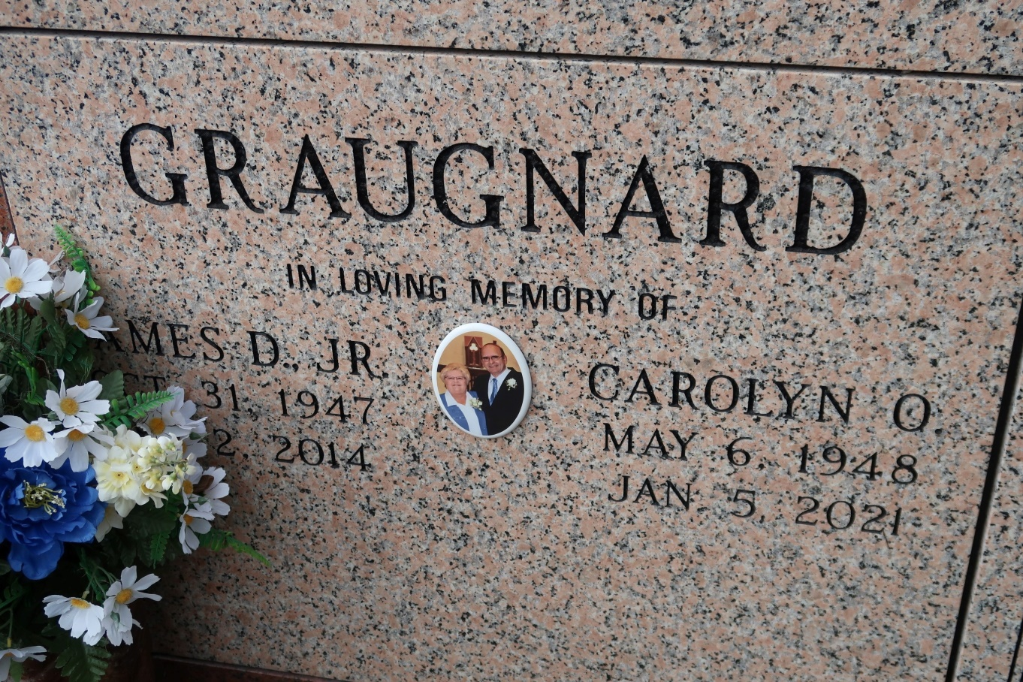

Carolyn Graugnard, a native of Vacherie, LA and a resident of Geismar, LA passed away on Tuesday, January 5, 2021 at the age of 72. She was a devoted wife, mother, sister, grandmother, great-grandmother and friend who will be greatly missed.

Carolyn was a parishioner of St. John the Evangelist Catholic Church where she devoted her time to the St. John Food Pantry. She retired from Ascension Catholic School where she was an Administrative Assistant for 26 years. She was a very spiritual woman who was involved in many church and community activities.

Carolyn is survived by two daughters, Rene' Theriot (Jay), Monique Standridge (Dean); son, James D. Graugnard III (Amber); brother, Lucien Ockmond, Jr. (Ann); five grandchildren, Alex Guedry (Tayler), Grace Graugnard, James D. Graugnard IV, Sydney Standridge, Makayla Bond and great grandchild, Christian Guedry.

She is preceded in death by her loving husband of 43 years, James Graugnard Jr.; parents, Marie "Gal" and Lucien Ockmond; maternal grandparents, Antoine and Antoinette Becnel and paternal grandparents, Onezeme and Olympe Ockmond.

The family would like to give a special thanks to Carolyn's caregivers at Home Instead Senior Care and Fresenius Kidney Care. In lieu of flowers, donations can be made to the Ascension Catholic Scholarship Fund in honor of Carolyn Graugnard at 311 St. Vincent St., Donaldsonville, LA 70346.

Private services will be held at this time. A Celebration of Life will occur at a later date due to the Covid pandemic. Nothing in life was more important to Carolyn than cooking and spending time with her family and friends.

The Advocate, Baton Rouge, Louisiana

January 6 - 8, 2021