James D. Graugnard Jr.

October 31, 1947 – February 2, 2014

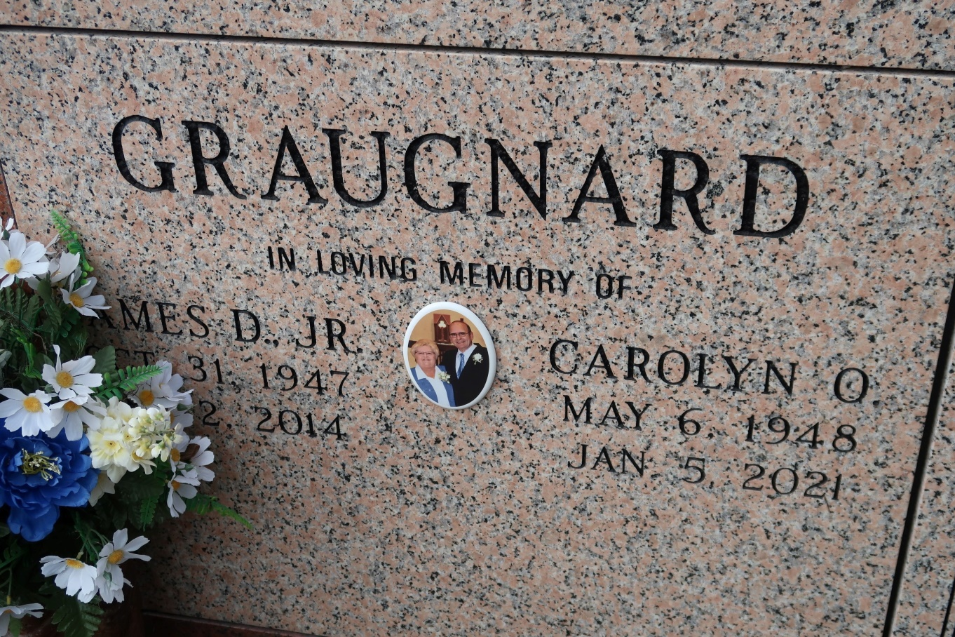

James D. Graugnard, Jr. 66, died on February 2, 2014. He was a native of St. James and was a sugar cane farmer for over 25 years.

James is survived by his loving wife of 43 years, Carolyn Ockmond Graugnard; three daughters and sons-in-law, René Graugnard and Jay Theriot, Monique Graugnard and Dean Standridge, and Jennifer Bourgeois and Buddy Aucoin; two sons and daughters-in-law, James, III, and Rebecca Graugnard, and Jeremy and Cindy Bourgeois; seven grandchildren, Alex, Grace, James, Sydney, Julia, Emma, and Madison; two sisters and brothers-in-law, Dr. Michael and Mary Graugnard Marcello and Nancy Graugnard and Randy Songy; three brothers and sisters-in-law, Gary and Gerri Graugnard, David and Paulette Graugnard, Lynn and Carrie Graugnard ; and numerous nieces and nephews.

Preceded in death by his parents, James and Bertha Graugnard; brother, Robert Graugnard; maternal grandparents, Premalis and Claudia Haydel; and paternal grandparents, Fortune and Tetere Graugnard.

Family would like to give a special thank you to the Transplant Physicians and team at Ochsner Medical Center in Jefferson. Also a special thanks to our family and friends who have supported us.

Visitation will be held on Wednesday, February 5, 2014 at 12:30 until Mass of Christian Burial at 2:30 p.m. at St. James Catholic Church in St. James. Entombment to follow in church mausoleum. Arrangements by Ourso Funeral Home in Donaldsonville.  In lieu of flowers, a memorial donation can be made to LOPA: [http://lopa.org/financial-contributions.](http://lopa.org/financial-contributions)

The Advocate, Baton Rouge, Louisiana

February 2 - 4, 2014