Frank Harris
Abt. 1952 – August 21, 2002

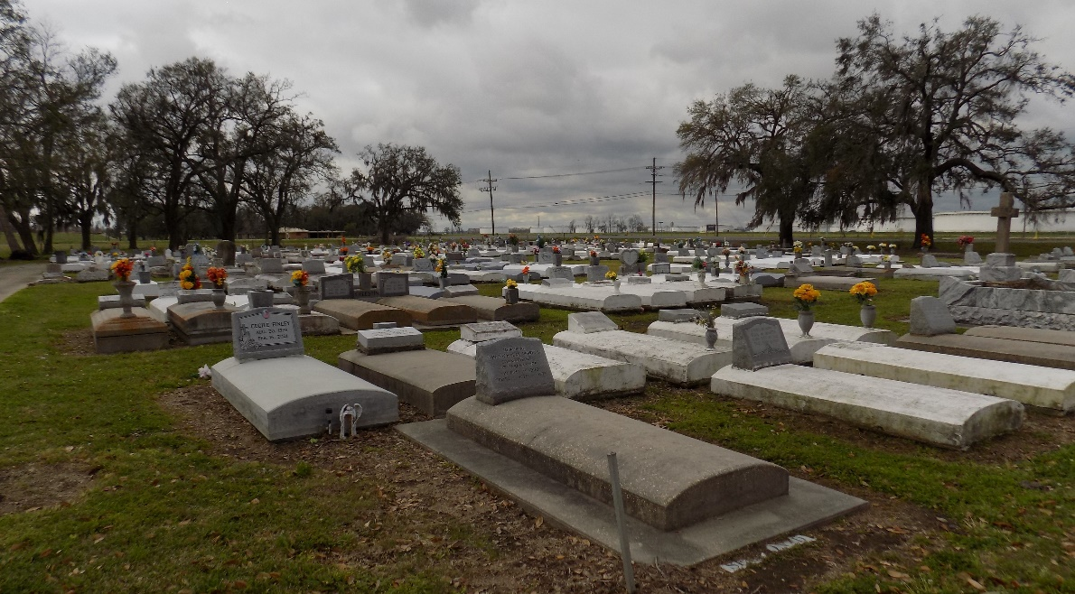

ST. JAMES – Frank Harris, 50, a native and resident of St. James, died Aug. 21. He was the son of Viola Harris and the late Daniel Harris Sr. and brother of Ethel Mae Keller, Daniel and Arthur Harris and the late Rosa Keller and Raymond, Louis and David Harris. Services are today at 11 a.m. at St. James Catholic Church, St. James, with interment at the church cemetery. Visitation starts at 9 a.m.
L’Observateur, LaPace, Louisiana
Tuesday, August 27, 2002

