Hilda M. (Nelson) Harris

December 16, 1917 – October 11, 2002

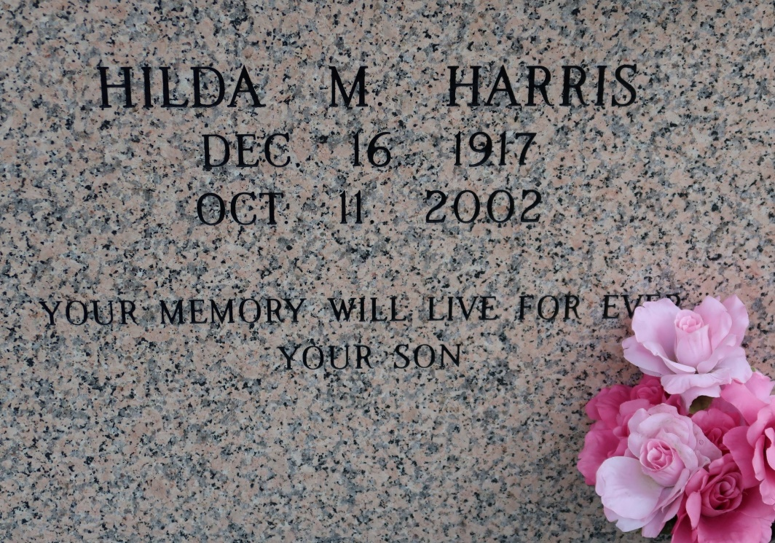

Hilda Nelson Harris, a retired domestic worker, died Friday at Memorial Medical Center. She was 84. Mrs. Harris was born in St. James and lived in New Orleans for the past 55 years. She was a parishioner of Holy Ghost Catholic Church.

Survivors include a son, Alvin J. Williams; a stepson, Joseph H. Harris; three brothers, Lionel Nelson Sr. of St. James, Norwood Nelson of Welcome and Victor Nelson; three grandchildren; and three great-grandchildren.

A Mass will be said Wednesday at 11 a.m. at St. James Catholic Church in St. James. Visitation will be today from 4 to 8 p.m. at Tilly's Funeral Home, 2831 St. Claude Ave., and Wednesday at 10 a.m. at the church. Burial will be in the church cemetery.

Times-Picayune, The (New Orleans, LA)

Tuesday, October 15, 2002