Linda Mae Himes

October 22, 1945 – October 20, 2014

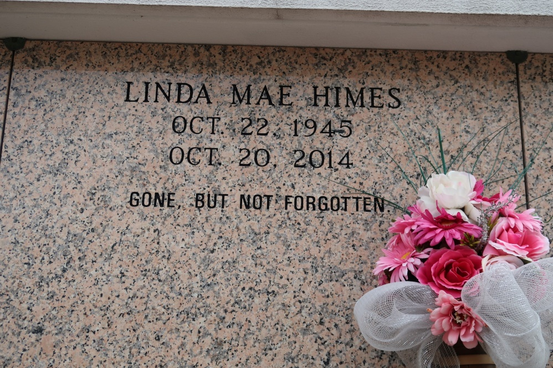

Linda Mae Himes, a native of St. James and a resident of Donaldsonville, she died at St. Elizabeth Hospital in Gonzales at 10:23 a.m., Monday, Oct. 20, 2014. She was 68.

Visiting at St. James Catholic Church, St. James, Monday, October 27, 2014, from 9:30 a.m. until Mass of Christian Burial at 11:00 a.m. conducted by Rev. Paul Yi. Entombment in St. James Catholic Church mausoleum.

Survived by two sisters: Patricia Lemieux and Glenda Washington; a brother, Donald Himes and wife, Cynthia; an aunt, Leona Landor; nieces, nephews, cousins, other relatives and friends.

Preceded in death by her parents, Octave Himes and Anide Nicholas Himes and a Brother, Larry Himes.   
 Brazier-Watson Funeral Home in charge of arrangements. Visit us at www.brazierwatson.com to sign our guest book.

The Advocate, Baton Rouge, LA

Thursday, October 23, 2014  
Contributed by Jane Edson