Clifton Adam Hymel, Sr.

April 10, 1924 – October 29, 2013

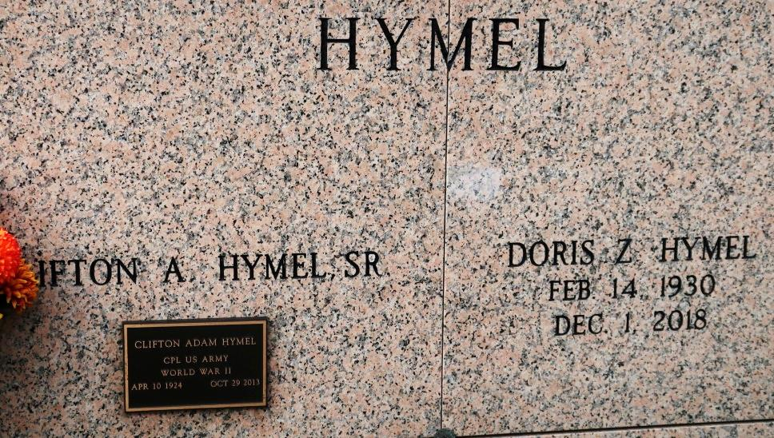

Clifton "Kippy" Adam Hymel, Sr., 89, died on Tuesday, October 29, 2013 at St. James Hospital surrounded by his loving family. He was a veteran of World War II. He retired from St. James Sugar Co-Operative. Kippy was an avid gardener and enjoyed cooking.

Kippy is survived by his loving wife of 63 years, Doris Zeringue Hymel; five children, Sandra Hymel Dutreix and husband Chris, Jeanie Hymel, Clifton Hymel, Jr. and wife Sharon, Thomas Hymel and wife Darlene, and Steven Hymel and wife Monica; grandchildren, Gregory Dutreix, Melissa and Jay Matherne, Marcie and Samuel Elliott, Alicia Hymel, Kristy and Adam Smith, Brent Hymel, Matthew Hymel, and Andrew Hymel; great grandchildren, Jean Paul Matherne, Jace Matherne, and Royston Elliott; four sisters, Edith Laurent, Lucille Bye, Therese Gonzales, and Amy Laurent; and one brother, Lloyd Hymel.

Preceded in death by his parents, Marie and George Hymel, Sr.; grandson, Bradley Hymel; sisters, Eunice Hymel and Mable Granier; and four brothers, George, Jr., Nelson, Merlin, and Ivy. Pallbearers will be Clifton Hymel, Jr., Thomas Hymel, Steven Hymel, Gregory Dutreix, Brent Hymel, and Matthew Hymel.

Visitation will be held on Thursday, October 31, 2013 at 8:30 a.m. until Mass of Christian Burial at 11:00 a.m. at St. James Catholic Church in St. James. Officiated by Rev. Christopher J. Decker. Entombment to follow in St. James Mausoleum. Arrangements by Ourso Funeral Home in Donaldsonville. In lieu of flowers, memorial donations can be made to the American Cancer Society.   
 Family would like to give a special thank you to the staff of Thibodaux Regional Medical Center and St. James Hospital for the care provided to Kippy. Condolences can be made at [www.oursodonaldsonville.com](http://www.oursodonaldsonville.com).

The Advocate, Baton Rouge, LA

Wednesday, October 30, 2013  
Contributed by Jane Edson